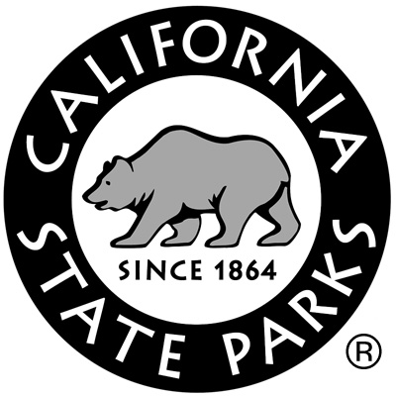
District #:
Unit(s) #:
Code:
Staff, please circle below:
Permanent Seasonal Volunteer

School Group Program Evaluation

Date(s) of Visit: Name of Park Program:
Teacher: Grade(s)(circle): K 1 2 3 4 5 6 7 8 9 10 11 12
Primary Subject for the trip: Number of students:
School: Phone #:
School Address: City: Zip:
Email Address:
For each section, please circle an appropriate letter grade,

A, B, C, D, or F, like a report card

Educational Content of Program Grade: A B C D F
Issues to consider: Did the program present unifying theme(s) and big ideas rather than just facts? Were ideas presented logically and connected to curriculum? Was the program connected to the students’ lives and society?

Usefulness to Students Grade: A B C D F
Issues to consider: Were instructional materials easy for students to use and understand? Was the program accessible for all students regardless of special needs such as those with limited English proficiency or learning disabilities? Was the layout of instructional materials for students interesting and appealing?

Presentation to the Student Grade: A B C D F
Issues to consider: Were the roles of environmental ethics or responsible citizenship explored? Did the program promote respect and caring for society or the environment, without being dogmatic? Were personal and societal values and conflicting points of view explored in a context that students could understand?

Using Current Educational Pedagogy Grade: A B C D F
Issues to consider: Did the program have the students engaged in active learning? Did the program base the students’ learning on their constructing knowledge through research, discussion, and application of their findings? Were the instructional materials and presentations sensitive to social, economic, and cultural diversity? Were group or cooperative learning strategies used?

Teacher Usability of Materials and Presentations Grade: A B C D F
Issues to consider: Were the learning objectives or outcomes clear and appropriate? How well did the materials integrate with educational content standards? Were the background materials and/or additional resources useful to you?

Reservations
- Did you make a reservation? (check one)  Yes  No

How did you make your reservation? (check one)
 ReserveAmerica  Commercial tour group  Contacted park directly
 Other:____________________________________  N/A
- How satisfied are you with the service you received when making your reservation? (check one)
 Very satisfied  Somewhat satisfied  Not satisfied  N/A
Comments on reservations?

Pre-Trip Information
- What information did you receive from California State Parks prior to your trip? (check all that apply)
 Reservation confirmation  Map/directions/parking information
 Pre- and post-trip activity sheets  Suggested readings/discussion topics
 Glossaries/definitions lists  Video
 Other:  None
- What types of information would be most useful to you? (indicate by numbering the items below, with 1 being the item of greatest usefulness and 7 being the least)
___Reservation confirmation ___Map/directions/parking information
___Pre- and post-trip activity sheets ___Suggested reading/discussion topics
___Glossaries/definitions lists ___Video
___Other:
- Would you utilize the internet to obtain such information?  Yes  No
Comments on pre-trip information?

Additional comments?

THANK YOU! We appreciate you taking the time to give us feedback on your experience.
Please return this form to:
[Fill in park, sector, or district office address here]

