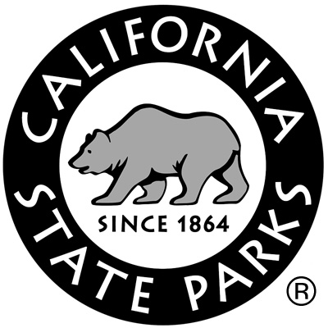
District #:
Unit(s) #:
Code:
Staff, please circle below:
Permanent Seasonal Volunteer

School Group Program Evaluation

Date(s) of Visit: Name of Park Program:
Teacher: Grade(s)(circle): K 1 2 3 4 5 6 7 8 9 10 11 12
Primary Subject for the trip: Number of students:
School: Phone #:
School Address: City: Zip:
Email Address:
For each section, please circle an appropriate letter grade,

A, B, C, D, or F, like a report card

Educational Content of Program Grade: A B C D F
Issues to consider: Did the program present unifying theme(s) and big ideas rather than just facts? Were ideas presented logically and connected to curriculum? Was the program connected to the students’ lives and society?

Usefulness to Students Grade: A B C D F
Issues to consider: Were instructional materials easy for students to use and understand? Was the program accessible for all students regardless of special needs such as those with limited English proficiency or learning disabilities? Was the layout of instructional materials for students interesting and appealing?

Presentation to the Student Grade: A B C D F
Issues to consider: Were the roles of environmental ethics or responsible citizenship explored? Did the program promote respect and caring for society or the environment, without being dogmatic? Were personal and societal values and conflicting points of view explored in a context that students could understand?

Using Current Educational Pedagogy Grade: A B C D F
Issues to consider: Did the program have the students engaged in active learning? Did the program base the students’ learning on their constructing knowledge through research, discussion, and application of their findings? Were the instructional materials and presentations sensitive to social, economic, and cultural diversity? Were group or cooperative learning strategies used?

Teacher Usability of Materials and Presentations Grade: A B C D F
Issues to consider: Were the learning objectives or outcomes clear and appropriate? How well did the materials integrate with educational content standards? Were the background materials and/or additional resources useful to you?

General Issues
- How useful was the pre-trip information (directions, pre-trip activities, resource materials, what to expect, etc.) provided to you? Grade: A B C D F
- What would you have liked?
- What did you receive?

- How suitable were the logistical arrangements (timing, meeting with people, etc.) for the trip at the state park? Grade: A B C D F
- What would have been ideal?
- What actually happened?

- How suitable were the accommodations (restrooms, parking, meeting space, etc.) at the park site(s) you visited? Grade: A B C D F
- What would you have liked?
- What did you find?

- Were the safety concerns for the trip adequately addressed? Grade: A B C D F
Comments:

What aspect of the program contributed the most to your students’ education?
Additional comments?

THANK YOU! We appreciate you taking the time to give us feedback on your experience.
Please return this form to:
[Fill in park, sector, or district office address here]

