I.

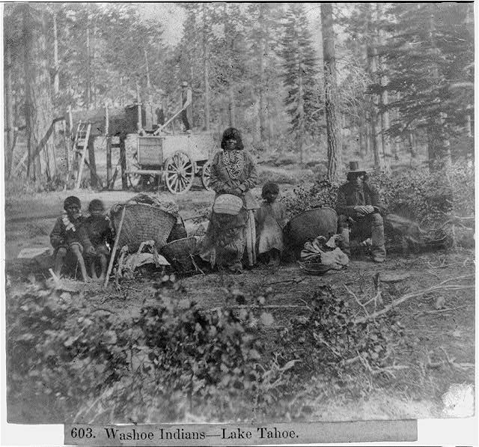
Lawrence & Houseworth, P. (1866) Washoe Indians--Lake Tahoe. , 1866. [Published] [Photograph] Retrieved from the Library of Congress, https://www.loc.gov/item/2002721338/.

*Images may be subject to change after lessons are piloted

II.

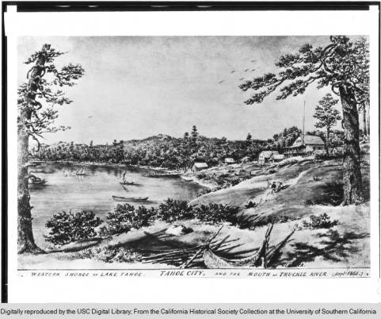
California Historical Society, P. (1860-1960) Drawing by Edward Vischer of Lake Tahoe and Tahoe City, California, September 1865. [Published] [Drawing] Retrieved from USC Libraries Special Collections, http://digitallibrary.usc.edu/cdm/compoundobject/collection/p15799coll65/id/1524/show/1522/rec/18.

*Images may be subject to change after lessons are piloted

III.

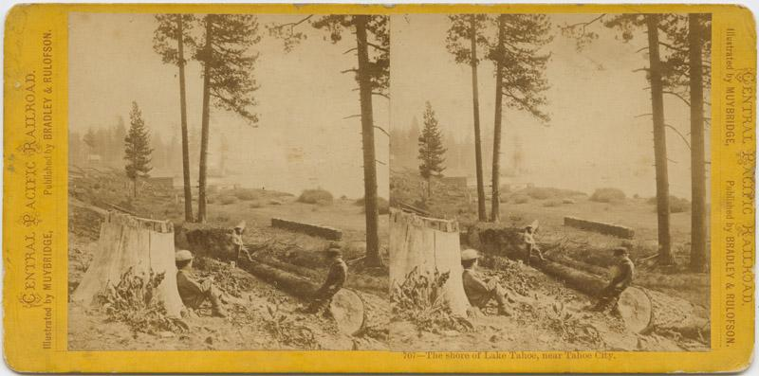
Edw. J. Muybridge, [ca. 1871] [Shore of Lake Tahoe] No. 39 [graphic]. Retrieved from California State Library Picture Catalog
http://catalog.library.ca.gov/F/6768PJTJXEQ7E4721ARGLA2MJ6SFYF5PYQ5G8H2QGM67X5C5Y7-08669?func=full-set-set&set_number=002924&set_entry=000001&format=999.

*Images may be subject to change after lessons are piloted

IV.

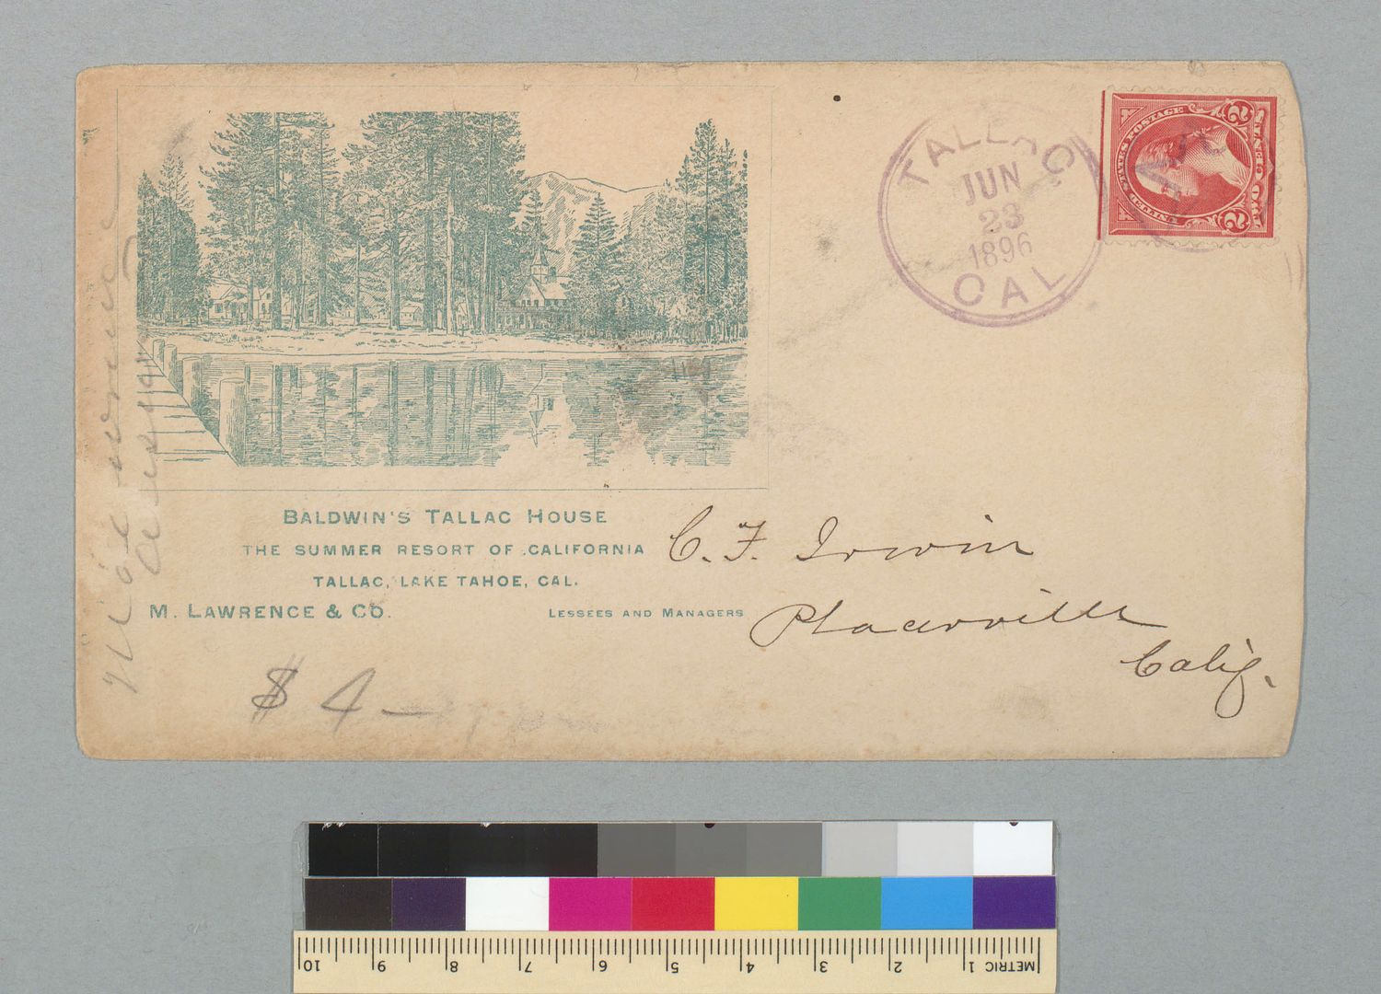

M. Lawrence & Co., P. Baldwin's Tallac House, the summer resort of California, Tallac, Lake Tahoe, Cal[ifornia], [1896]. [Published] [Engraving, Postcard] Retrieved from the UC Berkeley, Bancroft Library https://oac.cdlib.org/ark:/13030/tf0d5nb3kn/?brand=oac4 .

*Images may be subject to change after lessons are piloted

V.

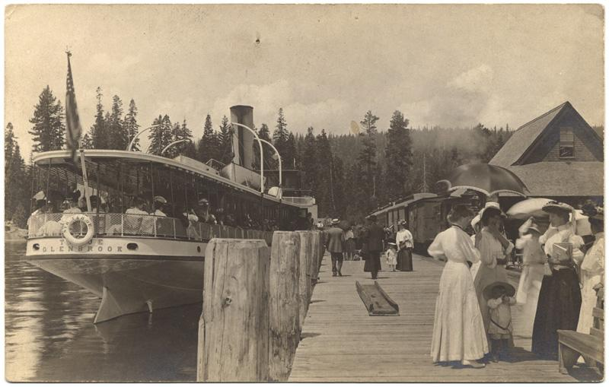
“View of the Steamer Tahoe excursion boat filled” with passengers and docked at the Tahoe Tavern pier in Tahoe City. A train is also seen on the pier.

E. F. Mueller Postcard Collection, California State Library. [Steamer Tahoe at Tahoe City] [between 1907 and 1914] [Postcard] Retrieved at Calisphere https://calisphere.org/item/c8559b46ab4ed13129f6650df8457abc/.

*Images may be subject to change after lessons are piloted

VI.

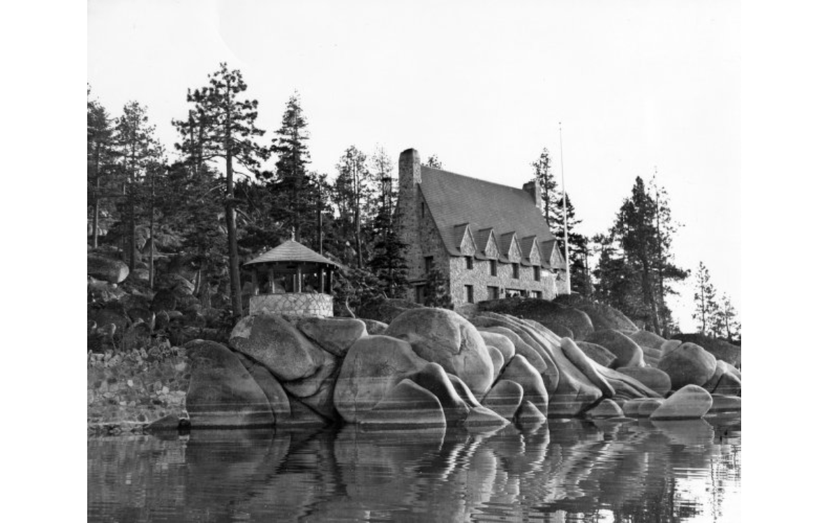

Whittell Estate, Lake Tahoe [1940] [Photograph]. Retrieved from UNR Digital Collections https://unr.dgicloud.com/islandora/object/tahoe%3Acollection_1965.

*Images may be subject to change after lessons are piloted
VII.

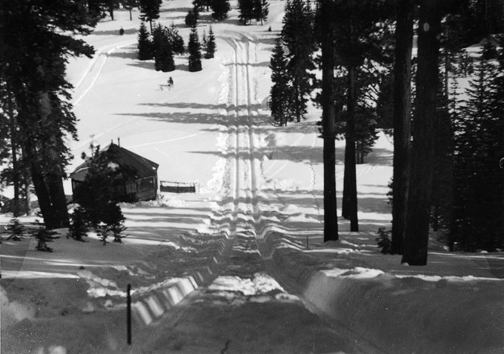
1928 Double Tobaggan Slide at Granlibakken, built under the supervision of George Bliss
http://granlibakken.com/granlibakken-ski-history/

*Images may be subject to change after lessons are piloted
*Proper citations and copyright will be finalized after lessons are piloted
VIII.

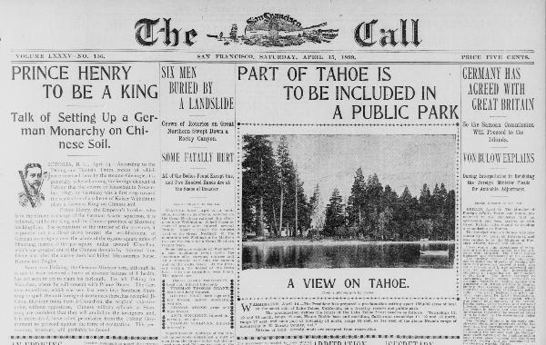

The San Francisco Call. (San Francisco [Calif.]), 15 April 1899. Retrieved from Chronicling America: Historic American Newspapers. Lib. of Congress. <http://chroniclingamerica.loc.gov/lccn/sn85066387/1899-04-15/ed-1/seq-1/>.
*Images may be subject to change after lessons are piloted

