Statewide Park

Development and

Community Revitalization Program
Month 2026
Round 5
draft application guide

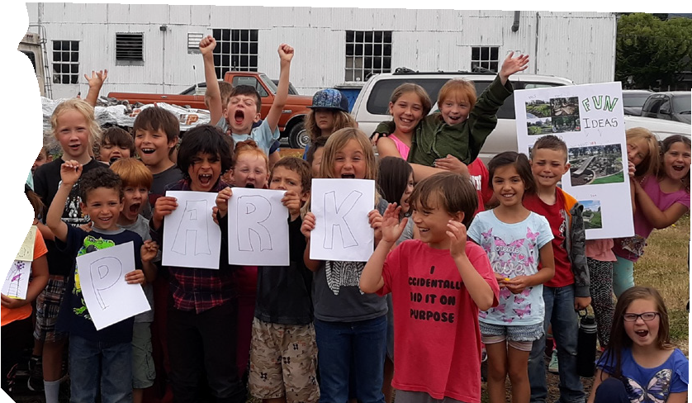

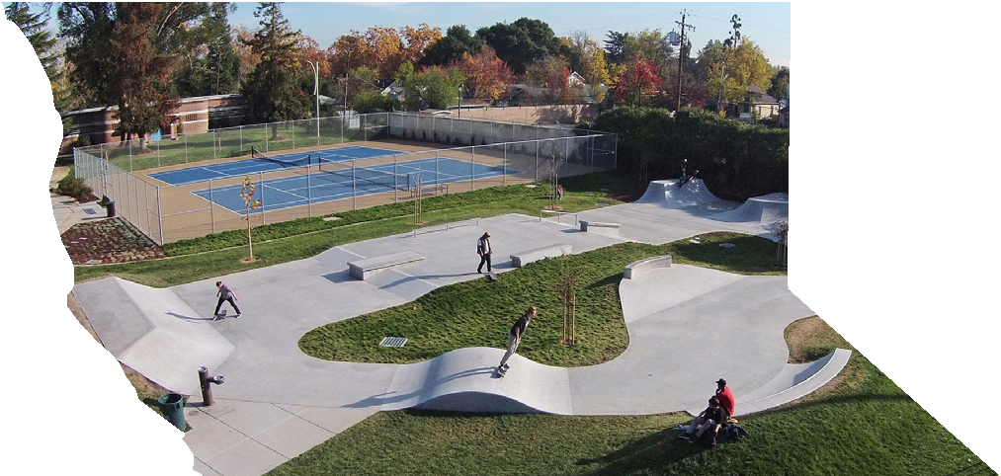

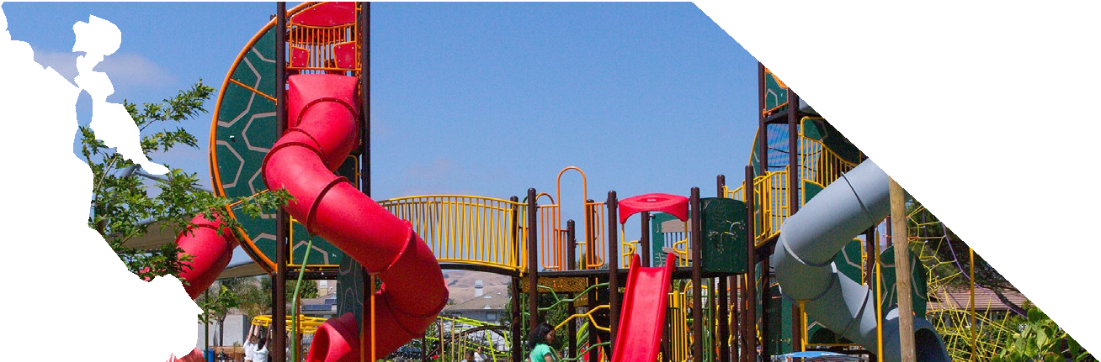

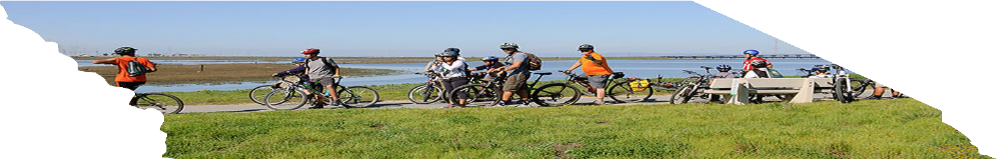


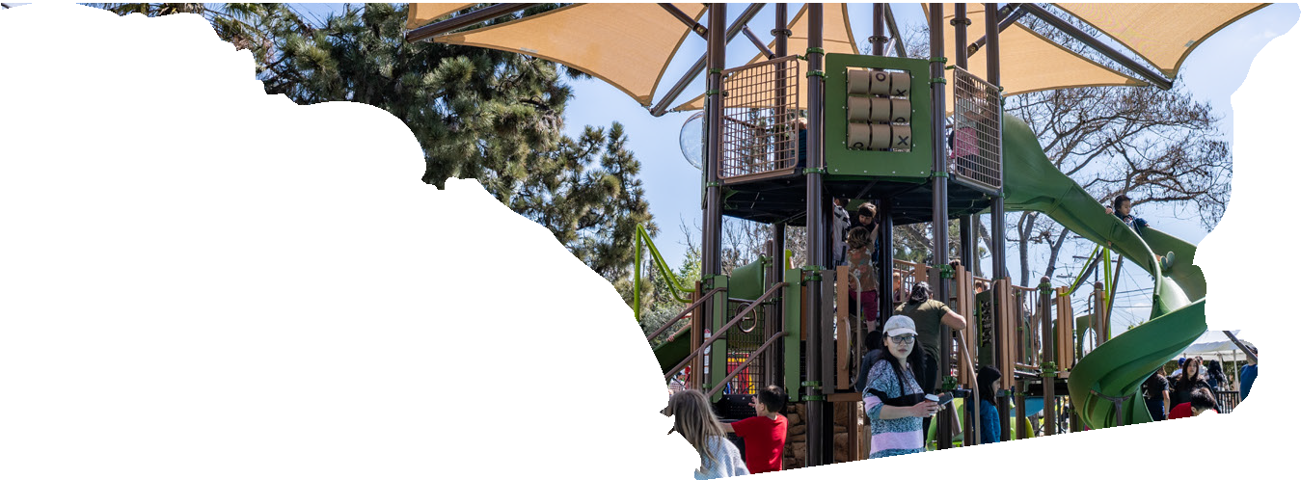
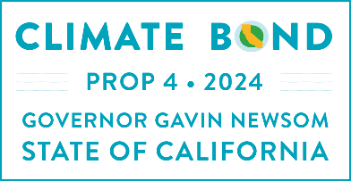

California Department of Parks and Recreation
Office of Grants and Local Services

California Department of Parks and Recreation
Office of Grants and Local Services
California Department of Parks and Recreation (DPR) MISSION
To provide for the health, inspiration, and education of the people of California by helping to preserve the state’s extraordinary biological diversity, protecting its most valued natural and cultural resources, and creating opportunities for high-quality outdoor recreation.
______________________________________________________________________
COMMUNITY ENGAGEMENT DIVISION (CED) MISSION
Encouraging healthy communities by connecting people to parks, supporting innovative recreational opportunities, embracing diversity, fostering inclusivity, and delivering superior customer service with integrity for the enrichment of all.
______________________________________________________________________
THE OFFICE OF GRANTS AND LOCAL SERVICES (OGALS) MISSION
To address California’s diverse recreational, cultural, and historical resource needs by developing grant programs, administering funds, offering technical assistance, building partnerships, and providing leadership through quality customer service.
OGALS’ VISION and GOALS
- Proactive in meeting California’s park and recreation needs through innovative grant programs and customer service.
- Committed to providing quality customer service in every interaction and transaction as honest, knowledgeable, and experienced grant administrators.
- Sensitive to local concerns while mindful of prevailing laws, rules, and regulations.
- Responsive to the needs of applicants, grantees, non-profit organizations, local governments, tribes, and legislative members, as partners working to improve the quality of life for all Californians by creating new parks and recreation opportunities.

Welcome to the Statewide Park Development and Community Revitalization Program
FOREWORD
Since 1965, statewide grants administered by ogals have created and improved over 8,000 parks. We look forward to continuing this legacy with grantees to improve the quality of life for communities throughout California.
Parks are unique places where children can play, families and friends bond, people exercise, older adults socialize, youth are mentored, cultures are celebrated, and everyone connects with nature. For these reasons and more, vibrant parks funded by this program will create humane and healthier communities. Building successful parks in underserved communities is “a work of art.” The Statewide Park Development and Community Revitalization Program (also referred to as Statewide Park Program or SPP) embraces meaningful engagement with residents where park designs represent each community’s unique recreation needs and creativity.
SPP is the largest park-related grant program in California’s history, with more than $1.2 billion in funding awarded through the 2018 Proposition 68 and 2006 Proposition 84 Bond Acts, along with State General Funds. To help capture the legacy and impact of these investments, “before and after” site photos are featured on www.parksforcalifornia.org.
With the addition of Round 5 funding through the 2024 Proposition 4 Climate Bond, the SPP program is anticipated to surpass $1.3 billion in total park investments supporting underserved communities throughout California.
Thank you for your interest in the Statewide Park Program!

APPLICATION GUIDE

Use the guidelines provided to plan the project. The online application and program updates are available at www.parks.ca.gov/spp.

CONTACT INFORMATION
The contact list is available at www.parks.ca.gov/ogals by clicking on “Contact Us” on the right side of the page or send an email to OGALS@parks.ca.gov.
Jacaranda Park, Los Angeles Neighborhood Trust SPP.

PROGRAM WEBSITE: www.parks.ca.gov/spp

List of Acronyms
CALCC California Association of Local Conservation Corps
CalRecycle California’s Department of Resources Recycling and Recovery
CCC California Conservation Corps
CED Community Engagement Division
CEQA California Environmental Quality Act
CFF Community FactFinder
DPR Department of Parks and Recreation
LEED Leadership in Energy and Environmental Design
OGALS Office of Grants and Local Services
SCH State Clearinghouse
SCORP Statewide Comprehensive Outdoor Recreation Plan
SPP Statewide Park Development and Community Revitalization Program (also referred to as the Statewide Park Program)

Words and terms appearing in small caps are defined in the back of the guide.

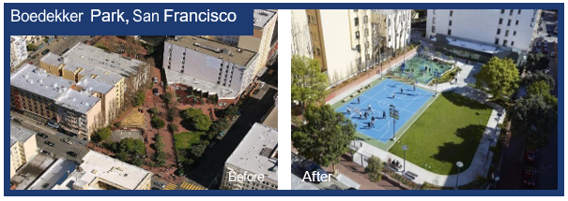
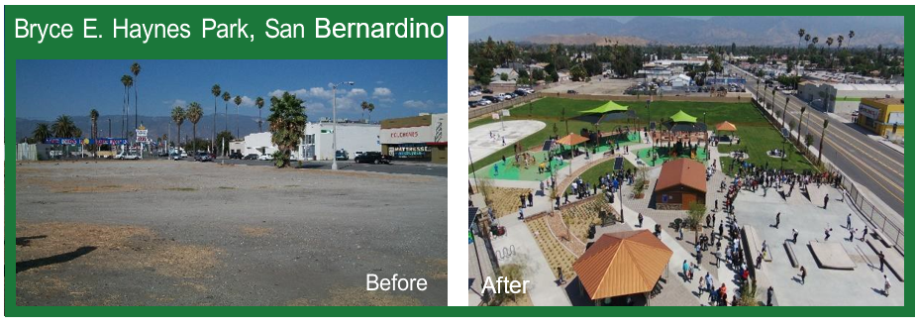
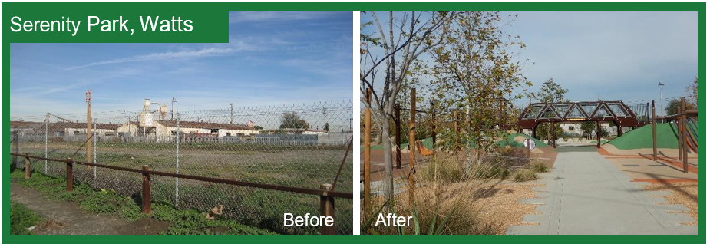
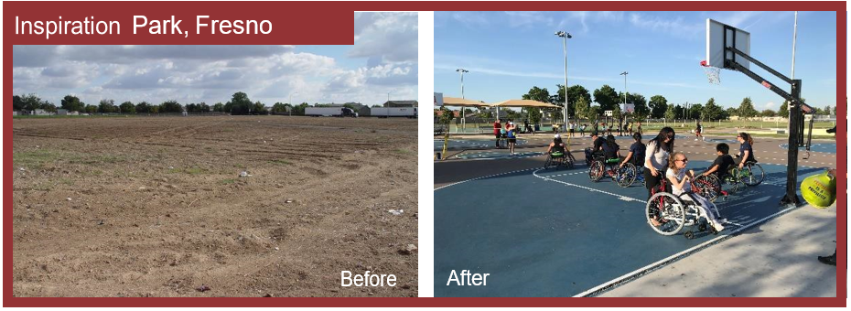
After
Before
After
Before
Before
After
After
Before

Table of Contents
I. Program Overview 1
Intent 1
Legacy 1
Eligible Applicants 1
Eligible Projects 1
Acquisition 1
Development 2
Major Support Amenities 2
Amount Available 3
Application Deadline 3
Grant Amount Per Application 3
Application Process 4
Grant Administration Process and Performance Period 4
II. Application Package
Application Instructions 7
application checklist (checklist items 1-15) 8
Checklist Item #1 - Application Form 9
Checklist Item #2 - Project Selection Criteria #1-10 11
Project Selection Criteria #1 – Critical Lack of Park Space 12
project selection criteria #2 – significant poverty 13
Project Selection Criteria #3 – Climate Vulnerable Populations 15
Project Selection Criteria #4 – Type of Project 16
Project Selection Criteria #5 – Community-Based Planning 18
Project Selection Criteria #6 – Employment or Volunteer Opportunities 23
Project Selection Criteria #7 – Partnerships or Committed Funding 25
Project Selection Criteria #8 - Environmental Design 26
Project Selection Criteria #9 – Public Use Fees and Hours of Operation 29
project selection criteria #10 – challenge(s), project Benefits and Readiness 30
Checklist ITem #3 - Community FactFinder Report and Certification Form 32
Checklist Item #4 - Authorizing Resolution Form 35
CHecklist Item #5.A, 5.B, and 5.C - Grant Scope/Cost Estimate Form, Indirect Cost Rate Form & Budget Narrative 37
Checklist Item #5.B - Indirect Cost Rate Instructions 41
Checklist Item #5.C - Budget Narrative 41
Checklist ITem #6 - Funding Sources 46
Checklist Item #7 - Project Timeline Form 48
Checklist item #8 - Applicant Capacity 52
Checklist Item #9 - PROJECT SITE Status: Owned, Acquisition, Lease and turn-key agreementS 53
Checklist Item #10 - Concept Level Site Plan 57
Checklist Item #11 - Photos and Copyright Agreement Form 58
Checklist Item #12 - Project Location Map 59
Checklist item #13 - Nonprofit Application Requirements 60
CHECKLIST ITEM #14 - CONSERVATION CORPS Consultation Process) 62
III. project Costs 64
Eligible costs 64
Ineligible Costs 67
IV. Appendices 68
Technical Assistance Resources 68
Project Selection Criteria #1-10 Guidance 70
Definitions for All Words and Terms in Small Caps 86

Program Overview

Intent
The Statewide Park Development and Community Revitalization Program (SPP) is a competitive grant program that creates new parks and new recreation opportunities in critically underserved communities across California.

Legacy
Previously, Proposition 84 (2006 Bond Act), Proposition 68 (2018 Bond Act), and 2021/22 and 2023/24 State General Funds supported four rounds of SPP:
$7.69 billion requested. $1.2 billion awarded.
180 new parks were/are being created, and 133 existing parks were/are being expanded or improved throughout California.
Proposition 4 (2024 Bond Act) passed on November 5, 2024, continues this program’s legacy. Projects funded by this proposition shall include signage informing the public that the project received funding from the Safe Drinking Water, Wildlife Prevention, Drought Preparedness, and Clean Air Bond Act of 2024. SPP legislation is found in Public Resources Code Sections 5640 through 5654. For more information, visit the California Natural Resources Agency’s Proposition 4 Climate Bond webpage.
Proposition 4 requires at least ten percent (10%) of the total amount available per ROUND to fund renovations of existing parks for increased use and access, including, but not limited to, individuals with disabilities, as defined by the Americans with Disabilities Act of 1990 (42 U.S.C. Sec.12101 et seq.).

Eligible Applicants

- Cities
- Counties
- districts
- joint powers authorities (one member of the joint powers authorities must be either an eligible district, City, or County)
- nonprofits with 501(c)(3) status

Eligible Projects
A project must involve either development or a combination of acquisition and development to:
- Create a new park, or
- renovate an existing park, or
- expand an existing park

The project site half-mile radius has:
- A ratio of less than three acres of parkland per 1,000 residents
or
- A median household income that is less than 80% of the California median household income
or
- project is within proximity to a climate vulnerability(ies)
applicants can check if their project is eligible with the Community FactFinder available under Community FactFinder Resources at www.parks.ca.gov/spp.

Acquisition
projects involving acquisition of land must be:
- Combined with development of a new recreation feature
OR
- Already have a recreation feature for public use at close of escrow
acquisition costs associated with condemnation or eminent domain are not eligible for reimbursement.
The land’s sale price may be up to, but cannot exceed, the appraised fair market value. State funds may not be used in part or whole to acquire property above the appraised value.
If a project is awarded, the following grant administration guidance must be followed:
- Purchase price cannot exceed the appraised value, even if the grantee is willing to pay the difference.
- Associated acquisition costs, such as appraisals, escrow fees, title insurance, etc., are considered pre-construction costs, which are limited to 25% of the grant.
- The grantee must record a deed restriction on the property after the acquisition is complete.
- grantee must provide title insurance.

Development
Create or renovate at least one recreation feature. development projects can also construct a new or renovate a major support amenity.
Recreation features
Examples of recreation features include but are not limited to the following:
- Aquatic center, swimming pool, splash pad, pond, fishing pier, and paddling launch site
- Amphitheater/performing arts, dance, music, and theater stage
- Athletic fields (soccer or futbol-rapido, baseball, softball, football, archery, etc.)
- Athletic courts (basketball, futsal, tennis, pickleball, bocce ball, shuffleboard, badminton, horseshoe/cornhole, batting cages, etc.)
- Community gardens, botanical gardens, demonstration gardens, orchards, outdoor education kitchen, meditation/calm zone, pollinator/butterfly garden, labyrinth garden
- Community/recreation center (only if in or adjacent to a park), outdoor classroom
- Dog park
- SNO-park
- Skate park and skating rinks
- BMX or pump tracks (non-motorized)
- Golf course (disc, mini, etc.), equestrian course, par course (solitary fitness stations)
- Jogging and walking loop, running track, trail (non-motorized), pedestrian/bicycle bridge, greenbelt/linear park
- Outdoor fitness area, obstacle course, ropes course, rock climbing wall, zip line
- Open space and natural area for public recreation use
- Picnic/BBQ areas, game tables
- Playground, tot lot, sensory/music play area, nature discovery zone, etc.
- Plaza, zocalo, gazebo, farmers market and food truck areas
- Public art (mosaic tiles, sculptures, murals)

Major Support Amenities
Examples of major support amenities include but are not limited to the following:
- Restroom building, snack shack
- Parking lot, staging area
- Pathway for access to a recreation feature or throughout the park
- Landscaping or lighting that will be constructed throughout the park
- Perimeter fencing around park
- Park security cameras, etc.
applications where the majority of the total project costs are for a major support amenity will be less competitive than projects that create new recreation opportunity(s). Projects should create a new recreation opportunity(s) as the primary goal.
applications only for major support amenities are ineligible; a project must create or renovate at least one recreation feature.

Amount Available
The amount available for each round and the grant performance period for SPP are announced at www.parks.ca.gov/spp.

Application Deadline
The application deadline will be announced at www.parks.ca.gov/spp.

Grant Amount Per Application
- Maximum grant request per application: $8,500,000
- Minimum grant request per application: $200,000
No Match Required: The grant amount by itself may fund the entire project.
Requested Grant Amount:
The requested grant amount cannot increase after the application deadline.

One park = One application:
Each park requires its own, separate application. Only one application, requesting up to $8.5 million, may be submitted for the same park.
Multiple parks = Multiple applications:
An applicant may submit multiple applications for different parks. Multiple grants are not allowed for one project site. An applicant can potentially receive multiple grant awards that total more than $8.5 million. There is no cap to the number of grants applicants may receive.

Application Process
- The applicant should review the Competitive Chart available under Documents at www.parks.ca.gov/spp. The Competitive Chart is an important technical assistance tool that outlines what needs to be prioritized and considered for a competitive SPP application.
- The applicant should review the SPP application Guide to understand all competitive application requirements in more detail.
- The applicant should participate in technical assistance methods, including application workshops and contacting ogals’ Competitive Team Project Officer.
- The applicant should review the grant administration guide, including contract provisions, to understand the requirements if the competitive application is selected for funding.
- The applicant should review application submission directions available on the SPP website: www.parks.ca.gov/spp. All applications must be submitted by the application deadline.
  - It is recommended that application(s) be submitted at least 24 hours before the application deadline to avoid technical or submission issues.
  - applicants should review, complete, and submit the fillable application forms available at www.parks.ca.gov/spp.
    - Only submit each required fillable form
    - All forms should be clear and legible
    - Either date-stamped electronic or original signatures are accepted
  - After submission, applicants may be contacted to correct or complete certain documents.
    - Exception: Checklist Item #2 - Project Selection Criteria responses must be completed by the application deadline. Placeholders and revisions will not be accepted.
- OGALS reviews applications. grant award decisions are announced approximately six months after the application deadline.

Grant Administration Process and Performance Period
- applicants who have been selected for award must attend a mandatory grant administration workshop.
- OGALS sends a grant contract to the selected applicant for review and signature after the applicant completes the mandatory administration workshop.
  - After the signed grant contract is returned and signed by ogals, the applicant becomes a grantee.
  - The grant performance period starts with the appropriation date. If the grant is awarded, eligible costs dating back to the appropriation date may be reimbursed.
- If awarded SPP grant funding, the grantee, as the Lead Agency, is responsible for complying with all applicable CEQA requirements. Effective July 1, 2025, Public Resources Code §21080.57 established a CEQA exemption for eligible public park and non-motorized recreational trail projects funded under the Safe Drinking Water, Wildfire Prevention, Drought Preparedness, and Clean Air Bond Act of 2024 (Proposition 4). The grantee, as the Lead Agency, is responsible for determining whether the project qualifies for the exemption or whether additional environmental review is required, as applicable. Additional CEQA compliance information is available at Statewide Park Program Grant Administration Resources.
- grantees must include signage at the project site during grant performance period and after project completion.
  - Signage is an Eligible cost (see page XX). See the grant administration guide for more information.
- grantees must meet reporting requirements for tracking benefits and outcomes of funded projects towards state goals.
- grantees must complete the project at least six months before the end of the grant performance period to guarantee final payment.
  - The grant performance period ends June 30; final payment processing can take up to six months due to the high volume of payment requests received near the end of each fiscal year. Final payment processing includes review of the project completion packet, needed revisions from the grantee, final project site inspection, and payment approval by OGALS Fiscal, DPR Accounting, and the State Controller’s Office (SCO).
- OGALS cannot guarantee final payment for project completion packets received after December 31. The SCO must issue all payments by June 30. Any unpaid grant funds after that date will return to the Legislature.
- GRANTEES are required to ensure operation and maintenance of the project site for 30 years. The 30-year period begins with the appropriation date.
- If the grantee is acquiring or owns the project land in fee simple, a Deed Restriction must be recorded on the title of the property before OGALS will approve any grant payments except an advance into escrow and pre-acquisition costs. A Deed Restriction restricts the title to the property, safeguarding the property for purposes consistent with the grant for the duration of the contract performance period.

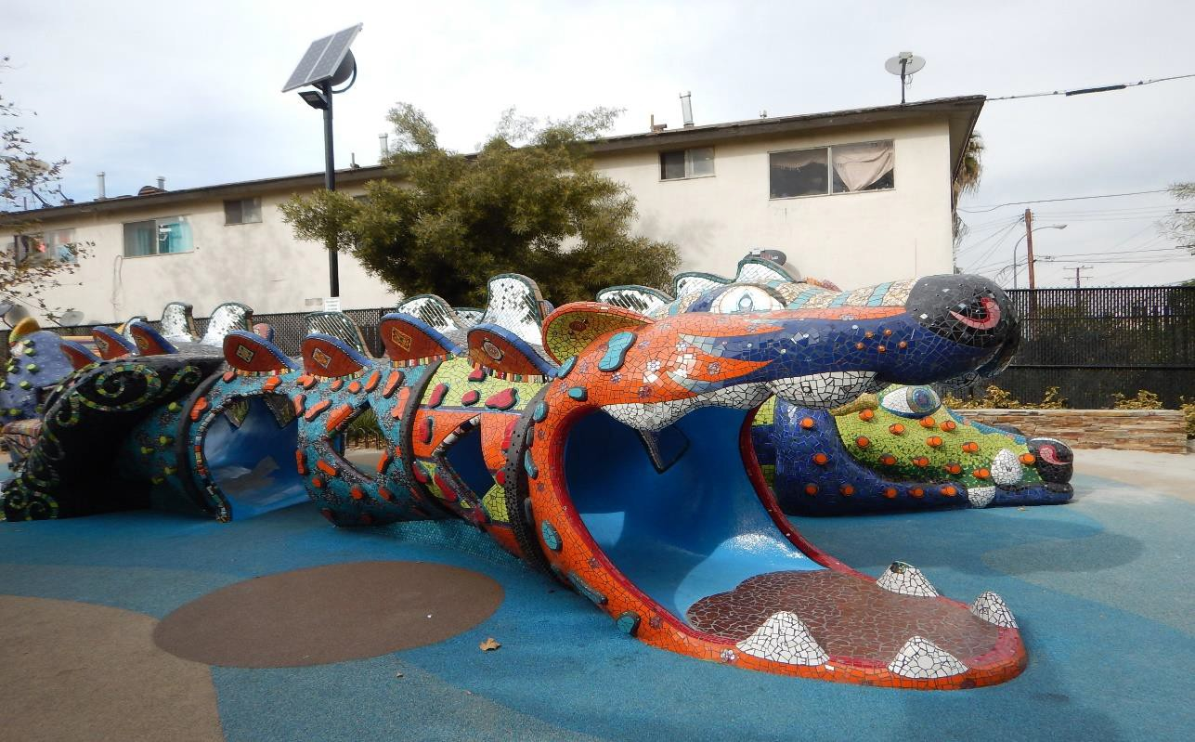
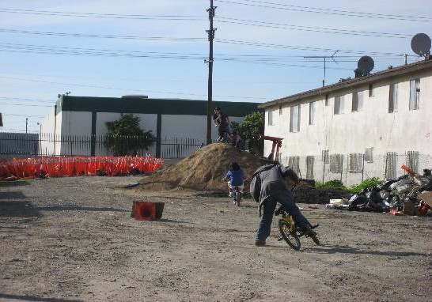
After
After
From blighted land to a vibrant park with soccer and play areas.
Shown above: Vacant land before, becomes Benito Juarez Park after.

After
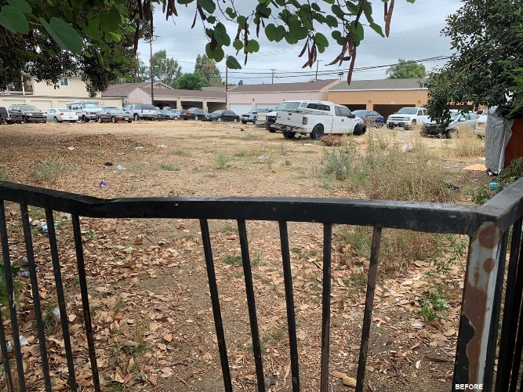
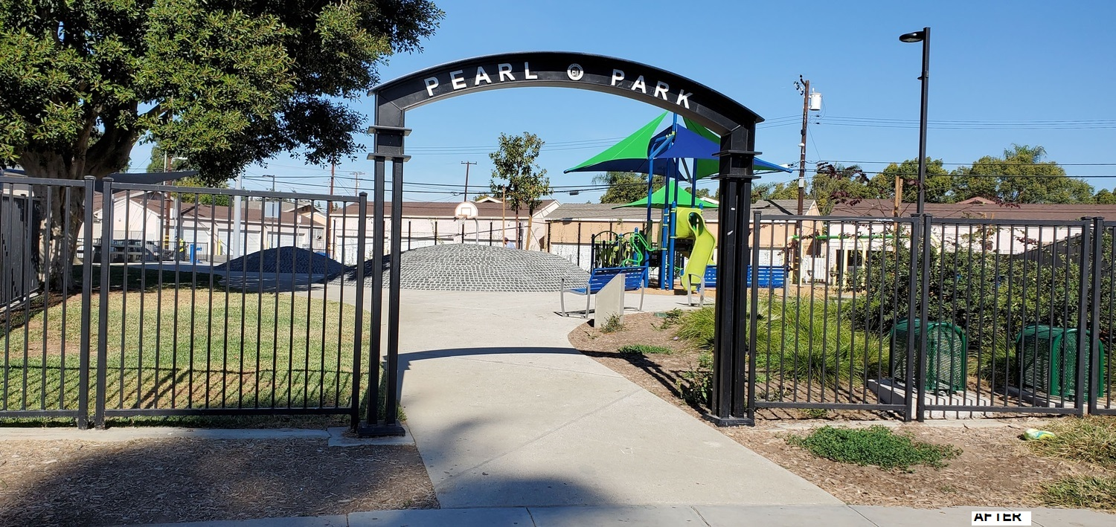
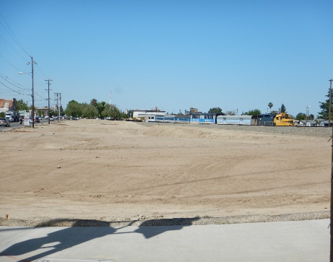
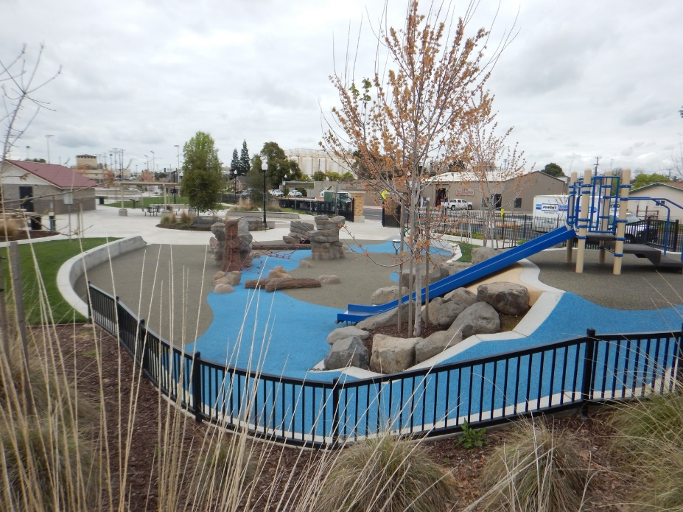
After
Before
After
A vacant overgrown lot becomes a neighborhood hub in the City of Fullerton.
Left: Pearl Park, before. Right: Pearl Park, after

Before
After
Before
After
A vacant three-acre lot is transformed into the new South Yosemite Avenue Community Park to include a skate park, central plaza, walking/jogging trail, and children’s play area.

Application Package
The application Package section provides detailed guidance to complete the application. As a reminder, each project site requires its own application. applications must be submitted by the application deadline posted on the SPP website: www.parks.ca.gov/spp.

Application Instructions
Use the following instructions to prepare the online application.
- Use the application Checklist on page XX to organize the application.
If additional time is needed to complete a checklist item, applicants should submit a one-page description (placeholder) for each checklist item. The placeholder must include the item status and the estimated date of completion. Upload placeholders in the online application system under the corresponding checklist item.
- EXCEPTION: Checklist item #2 – Project Selection Criteria must be completed by application deadline. Placeholders do not apply and will not be accepted.
- All required forms listed in the application Checklist are fillable and are available under FORMS at www.parks.ca.gov/spp.
- Only submit each required fillable form.
- Do not submit a screenshot image of any fillable form.
- Either date-stamped electronic or original signatures are accepted
- Provide only the items requested in the application Checklist.
- Do not provide supplementary materials, such as PowerPoint presentations, meeting sign-in sheets, survey results, etc.
- Do not send letters of support.
- Submit one application for each project site.
- Each project site requires its own application. Multiple project sites require multiple applications. An applicant may submit multiple applications for different project sites.
- Each application must be uploaded separately to the online application system at www.parks.ca.gov/spp by the application deadline.
- Do not mail a paper copy of the application.
- Keep at least one copy of the application package for your records.

Instructions and a video tutorial for the online application are posted at www.parks.ca.gov/spp.

application checklist (checklist items 1-15)
Use the application Checklist below to organize the application. Directions for each checklist item can be found on the page number listed below. Required forms are available under FORMS at www.parks.ca.gov/spp.
application Checklist |  | application Guide Page Number |  | Signed by authorized representative
 | 1. application Form | Pg. | 14
 | 2. Project Selection Criteria #1-10 | Pg. | 15 | N/A
 | 3. Community FactFinder Report and Certification Form | Pg. | 35
 | 4. Authorizing Resolution Form | Pg. | 37 | N/A
 | 5.A grant scope/Cost Estimate Form | Pg. | 38
 | 5.B indirect Cost Rate form | Pg.
 | 5.C Budget Narrative | Pg. |  | N/A
 | 6. Funding Sources Form | Pg. | 43
 | 7. project Timeline Form | Pg. | 44
 | 8. applicant Capacity | Pg. | 45 | N/A
 | 9. project site Status: Ownership, acquisition, or Lease | Pg. | 48 | N/A
 | 10. concept site level plan | Pg. | 50 | N/A
 | 11. Photos and Copyright License Agreement | Pg. | 51 | N/A
 | 12. project Location Map | Pg. | 52 | N/A
 | 13. nonprofit applicant Requirements  (nonprofit applicants only) | Pg. | 53 | N/A
 | 14. conservation corps Consultation Review | Pg. | 55 | N/A

Checklist Item #1 - Application Form
A fillable application Form (DPR #832A) is available under FORMS at www.parks.ca.gov/spp.
Requested Grant Amount: applicant will enter an amount within the minimum and maximum dollar amount allowable.
- All amounts must be rounded to the nearest whole dollar.
- The requested grant amount cannot increase after the application deadline.
Total Project Cost = Requested Grant Amount + Other Funding Sources
- The Requested Grant Amount and Other Funding Sources amount(s) must be consistent on:
  - Checklist Item #5.A – Grant Scope/Cost Estimate Form
  - Checklist Item #5.B – Indirect Cost Rate Form
  - Checklist Item #5.C – Budget Narrative
  - Checklist Item #6 – Funding Sources Form
Project Site Name and Physical Address - If a physical address is not available, applicant should provide the latitude and longitude coordinates.
Project Site Status: Ownership, Acquisition, or Lease – applicant will check one or more boxes and enter the acreage if applicable. If the proposed project site involves a combination of acquisition, lease, easement, or turn-key project agreements, verify that the required documents in Checklist Item #9 - Project Site Status: Ownership, Acquisition, or Lease are provided in the application.
Applicant Contacts -
- The authorized representative is the position, identified in Checklist Item #4 – Authorizing Resolution, who certifies that all the information in the application is accurate and signs all forms including the application Form, Community FactFinder Certification Form, grant scope/Cost Estimate Form, Indirect Cost Rate Form, Funding Sources Form, and project Timeline Form.
- The application Contact is the day-to-day administrator who can answer detailed questions about the application.
- The grant Contact will be the lead contact for grant administration if it is selected for funding. The “application” and “grant” contact may be the same person.

Checklist Item #2 - Project Selection Criteria #1-10
Overview
The Project Selection Criteria is used to evaluate and rank all applications. applicants must structure responses to follow the same numbered and lettered order of the Project Selection Criteria. A Project Selection Criteria Response template is available at www.parks.ca.gov/spp to help applicants organize their responses.
applicants must structure their Project Selection Criteria responses using the tables and prompts provided in the online application portal.
All Project Selection Criteria responses must be completed and submitted by the application deadline. Revisions to the Project Selection Criteria will not be accepted after the application deadline.
applicants are encouraged to design a new project based on the Project Selection Criteria. Technical assistance for Project Selection Criteria #1-10 begins on page XX.
The maximum score is 100 points.
P R O J E C T S E L E C T I O N C R I T E R I A #1-10 |  | M A X P O I N T V A L U E
1. | Critical Lack of park space | 15
2. | Significant Poverty | 13
3. | Climate Vulnerable Populations | 5
4. | Type of project | 10
5. | Community-Based Planning | 18
6. | Employment or Volunteer Opportunities | 5
7. | partnerships or Committed Funding | 3
8. | Environmental design | 7
9. | Public Use Fees and Hours of Operation | 4
10. | Community challenges, project Benefits and Readiness | 20
M A X I M U M S C O R E |  | 100
- All applications start with zero points. Points are earned through the Project Selection Criteria #1-10.
- If an application has any criteria resulting in “Ineligible project”, it will no longer be considered for a grant award.

Project Selection Criteria #1 – Critical Lack of Park Space
Using the Community FactFinder (CFF) report, provide information about the critical lack of park space within proximity (a half-mile radius) of the project site. Information on and access to the CFF report is available under Community FactFinder at www.parks.ca.gov/spp and on page XX.
Project Selection Criteria #1: applicants should use the table format below in the online application portal to structure a response to Project Selection Criteria #1.
Ratio of PARK acreage per 1,000 RESIDENTS according to the Community FactFinder Report | Community FactFinder Report ID Number  (located on the top left corner of the report)

applicants should also answer the following:
1: What is the ratio of park acreage per 1,000 residents within proximity of the project site according to the Community FactFinder Report?
Points: The scale below shows projects can earn up to 15 points based on their proximity to critically underserved communities with the lowest ratio of park space per 1,000 residents when compared to all applications. ogals will develop a statewide list representing the park space per 1,000 residents of all applications in ranking order, from lowest to highest.
 | Points
Lowest 10% on the ranked list | 15
From 11%-20% on the ranked list | 13
From 21%-30% on the ranked list | 11
From 31%-40% on the ranked list | 9
From 41%-60% on the ranked list | 7
From 61%-80% on the ranked list | 5
From 81%-100% on the ranked list | 3
No information provided. | 0
The project site’s half-mile radius has a ratio of more than three acres of park space per 1,000 residents and the community has a median household income above the median household income threshold and the project is not in proximity to climate vulnerability(ies). | Ineligible  project
Technical assistance begins on page XX.

project selection criteria #2 – significant poverty
Using the same CFF Report from Project Selection Criteria #1, provide information about significant poverty within proximity of the project site by answering the questions for Project Selection Criteria 2(A) and 2(B).
Project Selection Criteria #2(A): applicants should use the table format below in the online application portal to structure a response.
The “Median Household Income” according to the Community FactFinder Report | Community FactFinder Report ID Number (located on the top left corner of the report)
applicants should also answer the following:
2(A): What is the median household income within proximity of the project site according to the Community FactFinder Report?
Points: The scale below shows projects can earn up to eight points based on their proximity to critically underserved communities with the lowest median household incomes compared to all applications. ogals will develop a statewide list representing the median household incomes of all applications in ranking order, from lowest to highest.
 | Points
Lowest 10% on the ranked list | 8
From 11%-20% on the ranked list | 7
From 21%-40% on the ranked list | 6
From 41%-60% on the ranked list | 5
From 61%-80% on the ranked list | 4
From 81%-100% on the ranked list | 3
No information provided. | 0
The project site’s half-mile radius has a ratio of more than three acres of park space per 1,000 residents and the community has a median household income above the median household income threshold and the project is not in proximity to climate vulnerability(ies). | Ineligible project

Technical assistance begins on page XX.

Project Selection Criteria 2(B): applicants should use the table format below in the online application portal to structure a response to Project Selection Criteria 2(B).
Number of “People Living in Poverty” according to the Community FactFinder Report | Community FactFinder Report ID Number (located on the top left corner of the report)

applicants should also answer the following:
2(B): What is the number of people living below poverty within proximity of the project site according to the Community FactFinder Report?
Points: The scale below shows that projects can earn up to five points based on their proximity to critically underserved communities with the highest number of people below the poverty level compared to all applications. ogals will develop a statewide list representing the number of people living in poverty of all applications in ranking order, from highest to lowest.
 | Points
Highest 10% on the ranked list | 5
From 11% to 20% on the ranked list | 4
From 21% to 50% on the ranked list | 3
From 51% to 80% on the ranked list | 2
81% to 100% on the ranked list | 1
No information provided. | 0
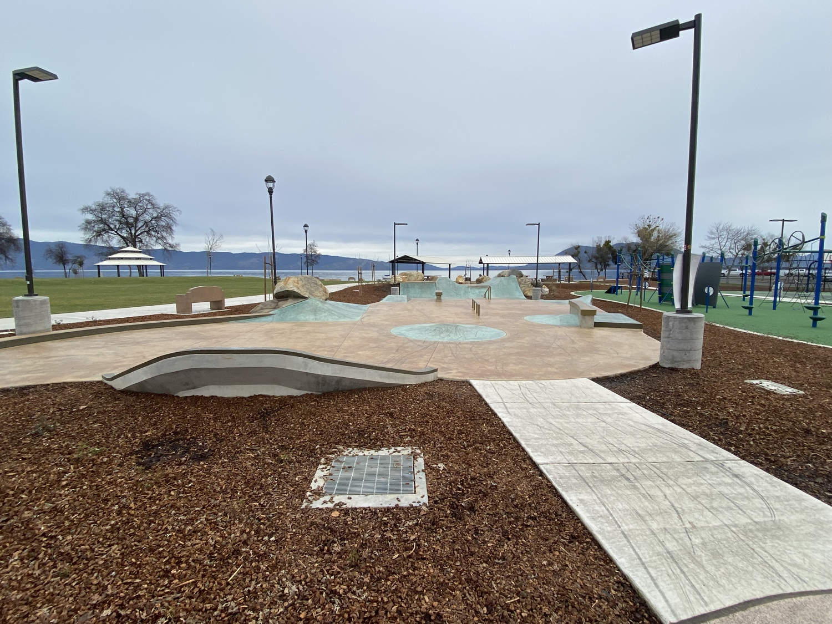
Technical assistance begins on page XX.
Lakeport Lakefront New Park, City of Lakeport. SPP.
project selection criteria #3 – climate vulnerable Populations
Using the same CFF Report from Project Selection Criteria #1, to identify the number of climate vulnerabilities listed for Project Selection Criteria #3.
applicants should answer the following:
3: What is the number of high-ranking climate vulnerabilities within proximity of the project according to the Community FactFinder Report?
Points: The scale below shows that up to five points can be earned for projects with three (3) or more high-ranking climate vulnerabilities within proximity of the project site.
 | Points
The community has three or more high-ranking climate vulnerabilities. | 5
The community has at least two high-ranking climate vulnerabilities. | 3
The community has one high-ranking climate vulnerability. | 2
No information provided or the community has no high-ranking climate vulnerabilities. | 0
The project site’s half-mile radius has a ratio of more than three acres of park space per 1,000 residents and the community has a median household income above the median household income threshold and the project is not in proximity to climate vulnerabilities. | Ineligible  project
Technical assistance begins on page XX.

Project Selection Criteria #4 – Type of Project
T Y PE O F P RO JE CT | Q UA LIF IE R S  (Respond based on the type of project)
(Check one of the following) | Q UA LIF IE R S  (Respond based on the type of project)
□ new park | Describe how the project site qualifies as a new park by answering the following:  (A) What was the use of the project site prior to the SPP application due date?  - Describe how the property to be developed into a new park was not used as a park and did not exist as a park before the application due date.  - Explain how the park is not adjacent to existing park space.
□ renovate an existing park | Describe how the project qualifies as a renovation of an existing park by answering the following:  (A) What is the total number of recreation feature(s) that will be added or renovated in the existing park?  (B) Why will each recreation feature(s) be added or renovated in the existing park?
□ expand an existing park | Describe how the project site qualifies as an expansion of an existing park by answering the following:  (A) What was the use of the expansion property prior to the application due date?  (B) Why is the expansion property currently not considered part of the existing adjacent park boundary?  (C) Describe why expansion is needed to complement the adjacent existing park.
applicants should use the following format to structure the response in the online application portal. Explain if the PROJECT will create a new park, renovate an existing park, or expand an existing park.
Technical assistance begins on page XX.
Project Selection Criteria #4 – Type of Project
Points: The scale below shows ten points can be earned for projects that create a new park.
 | Points
The project will create a new park. | 10
The project will add or renovate one or more recreation feature(s) in an existing park. The applicant provided the total number of and described why each recreation feature(s) will be added or renovated.  The project will not expand an already existing park or create a new park. | 9
The project will expand an already existing park. The expansion property is not park space and has not been part of the adjacent park before the current round’s application due date. | 8
The project will add or renovate one or more recreation feature(s) in an existing park. The applicant did not include the total number or describe why each recreation feature(s) will be added or renovated.  The project will not expand an already existing park or create a new park. | 5
project does not create a new park, or renovate or expand an existing park | Ineligible  project
Technical assistance begins on page XX.

Project Selection Criteria #5 – Community-Based Planning
Project Selection Criteria #5 has three parts: A, B, and C. Describe how the applicant or partnering organization(s) made efforts after November 5, 2024 (passage of Proposition 4), to engage residents to design the park. Use 5(A), and 5(B) to plan each meeting location, schedule and outreach. Use the three design goals in 5(C) to gather residents’ ideas at the meetings. applicants can find community-based planning resources under Technical Assistance Resources at www.parks.ca.gov/spp. meetings held before November 5, 2024, may be listed for historical reference, but will not contribute to points earned.
Project Selection Criteria #5(A) – applicants should use the table format below in the online application portal to structure the detailed list for each meeting held within the critically underserved community.

Meeting Date  Day/Month/Year | Day of the Week | Start and End Time (am/pm) | Meeting  Venue and Address | Reason for meeting location and time
applicants should also answer the following:
5(A): How many meetings have occurred in the critically underserved community? Describe why the meeting locations and times were convenient for residents with various schedules who may lack private transportation.
Points: The scale below shows that up to four points can be earned for the number and convenience of meetings held within the critically underserved community.
 | Points
The applicant or partners facilitated at least five meetings between November 5, 2024, and the application deadline to obtain ideas from the residents. The meetings were located within the critically underserved community or within a convenient distance for residents without private transportation. At least two of the meetings were held on a weekend or in the evening. | 4
Four or three meetings, between November 5, 2024, and the application deadline, were located within the critically underserved community or within a convenient distance for residents without private transportation.  One of the meetings was held on a weekend or in the evening. | 2
Two or one meetings, between November 5, 2024, and the application deadline, were located within the critically underserved community or within a convenient distance for residents without private transportation.  One of the meetings was held on a weekend or in the evening. | 1
meetings were not located within the critically underserved community or within a convenient distance for residents without private transportation, or none of the meetings occurred during a weekend or an evening, or between November 5, 2024, and the application deadline. | 0
Technical assistance begins on page XX.
Project Selection Criteria #5(B) - Applicants should use the table format below in the online application portal to structure their response. applicants must list meetings in order of response to 5(A).
Meeting Date/Year | Description of method(s) used to invite residents to this meeting (see page XX for a list of examples) | Number of residents who participated in this meeting | General description of residents (youth, older adults, tribal members, etc.) who participated in each meeting.

applicants should also answer the following:
5(B): For each meeting listed in response to 5(A), what method(s) were used to invite residents? In the combined set of meetings, describe how there was a broad representation of residents.

Points: The scale below shows up to four points are earned when at least three methods were used to invite a broad representation of residents.
Meeting Methods | Points
For the combined set of meetings, at least three methods were used to invite a broad representation of residents. | 3
For the combined set of meetings, two methods were used to invite a  broad representation of residents. | 2
For the combined set of meetings, one method was used to invite a  broad representation of residents. | 1
The methods used were limited to inviting only advocacy groups likely to promote a specific type of project or no method was used to invite residents. In either case, zero points will also be earned for #5(C). | 0
community representation | Points
The number and general description of the residents who participated in the combined set of meetings reflected a broad representation of the critically underserved community. | 1
- The number and general description of residents who participated in the combined set of meetings did not reflect a broad representation of the critically underserved communities  - Only an advocacy group or league likely to promote a specific type of project was involved.  - No residents were invited, or meetings did not occur.  In all cases, zero points will also be earned for #5(C). | 0
Technical assistance begins on page XX

Project Selection Criteria #5(C) – applicants should use the format below to structure their response to 5(C) – Goals 1, 2, and 3 in the online application portal to describe how RESIDENTS were engaged in the decision-making process. The process empowers residents and ensures they are represented in the final project.
applicants should also answer the following:
5(C): During meetings that occurred in the critically underserved community, how were residents empowered to design the park using Goals 1-3?
Goal 1: residents engaged in a process to reach a general agreement on the selection of the recreation feature(s) and design elements. The goal is to ask RESIDENTS what facilities and detailed design elements they want in the PARK
Selection of the recreation feature(s)
- Process: Describe how the residents were enabled to identify, prioritize, and then select recreation feature(s) for the proposed project.
- List of recreation features: ONLY list residents’ ideas that will be included in the site plan.
Design elements of the recreation feature(s)
- Process: Describe how the residents were enabled to provide design elements for the selected recreation feature(s).
- List of design elements: ONLY list residents’ ideas that will be included in the detailed design of the selected recreation feature(s).
Goal 2: residents engaged in a process to reach a general agreement on the selection of the recreation feature(s) within the park. The goal is to ask RESIDENTS their preferences for location(s) of selected recreation feature(s).
Location of the recreation feature(s) within the park
- Process: Describe how residents were enabled to provide their preferences for the location of the selected recreation feature(s).
- List of reasons: ONLY list residents’ reasons for the location of the selected recreation feature(s).
Goal 3: residents engaged in a process to provide other park design ideas, including solutions for climate vulnerabilities, safe public use and park beautification.
Solutions for Climate vulnerabilities, Safe public use and park beautification
- Process: Describe the process that enabled residents to provide park design ideas for climate vulnerabilities, safe public use and park beautification.
- Climate vulnerabilities: ONLY list residents’ ideas included in the project.
- Safe public use: ONLY list residents’ ideas included in the project.
- Park beautification: ONLY list residents’ ideas included in the project.
Points: The scale below shows that up to ten points cumulatively can be earned for MEETING goals 1-3 that enabled the RESIDENTS to DESIGN the PARK.
GOAL 1 – Selection of Recreation Feature(s) and Design Elements | Points
(a) and (b) The RESIDENTS identified and selected their preferred RECREATION FEATURE(S) not limited by predetermined options presented by the APPLICANT. A list of only the RESIDENTS selected RECREATION FEATURES for the proposed PROJECT has been provided. | 2
(c) The RESIDENTS provided ideas for DESIGN ELEMENTS for selected RECREATION FEATURE(S). | 1
(d) A list of the RESIDENTS’ ideas for DESIGN ELEMENTS that will be implemented for specific RECREATION FEATURE(S) has been provided. | 1
The APPLICANT’S response does not address any Goal 1 elements. | 0
GOAL 2 – Location of Recreation Features | Points
(a) The RESIDENTS expressed their reasons for the location of the RECREATION FEATURE(S) within the PARK. | 1
(b) A list of the RESIDENTS’ reasons for the location of the RECREATION FEATURE(S) that will be implemented within the PARK has been provided. | 1
The APPLICANT’S response does not address any Goal 2 elements. | 0

GOAL 3 – Climate Vulnerabilities, Safe Public Use, and Park Beautification | Points
(a) The RESIDENTS provided and selected their preferred ideas for climate vulnerabilities, safe public use, and park beautification. | 1
(b) A list of the RESIDENTS’ ideas regarding climate vulnerabilities that will be implemented within the PARK has been provided. | 1
(c) A list of the RESIDENTS’ ideas regarding safe public use that will be implemented within the PARK has been provided. | 1
(d) A list of the RESIDENTS’ ideas regarding park beautification that will be implemented within the PARK has been provided. | 1
The APPLICANT’S response does not address any Goal 3 elements. | 0
Technical assistance beings on page XX.
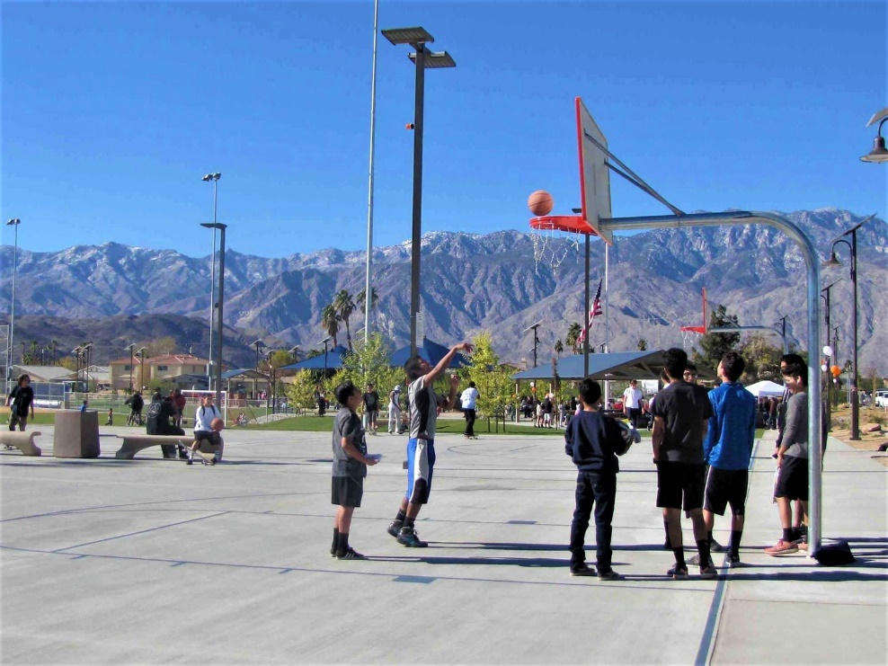
Ocotillo Park, Cathedral City. SPP.

Project Selection Criteria #6 – Employment or Volunteer Opportunities
Project Selection Criteria #6 has three parts: A, B, and C. applicants should describe how the project will include employment or volunteer outdoor learning opportunities for residents.
In addition to employment or volunteer opportunities for residents, applicants should contact a certified conservation corps to discuss the feasibility of using their services. For 6(C), provide the outcome of the certified Corps Consultation Process.
Project Selection Criteria #6(A) and (B): applicants should use the table format below in the online application portal to structure their list of each opportunity provided for 6(A) and 6(B).
6(A) Brief Description of Meaningful Employment or Volunteer outdoor learning opportunities | 6(B) Number of residents and/or certified corps members
applicants should also answer the following:
6(A): What types of meaningful employment or volunteer activities will be available for residents and/or certified corps members between November 5, 2024 (passage of Proposition 4), until project completion? (See examples on page XX)
6(B): How many residents and/or certified corps members will receive the outdoor learning opportunities?
Points: The scale below shows up to three points can be earned for PROJECTS that will include employment or volunteer outdoor learning opportunities for at least 20 residents and/or certified corps members.
 | Points
20 or more residents and/or certified corps members will receive employment or volunteer outdoor learning opportunities. | 3
Between ten and 19 residents and/or certified corps members will receive employment or volunteer outdoor learning opportunities. | 2
Between five and nine residents and/or certified corps members will receive employment or volunteer outdoor learning opportunities. | 1
The project will not provide employment or volunteer outdoor learning opportunities for at least five residents and/or certified corps members, or the applicant did not respond to the criteria. | 0
Technical assistance begins on page XX.

Project Selection Criteria #6(C): applicants should answer the following:
6(C): What was the outcome of the certified Corps Consultation Process? (See Checklist Item #15, pages XX-XX)
- If it is feasible for a certified conservation corps to work on a project component, provide a description of the agreed scope of work. Confirm an understanding between the applicant and certified conservation corps that the agreed scope of work is binding should the grant be awarded.
- If a certified conservation corps offered services but the applicant declined, provide a reason for not using their services.
Points: The scale below shows up to two points can be earned for projects that include employment of a certified conservation corps, or the certified conservation corps determined it is not feasible to work on the project.
 | Points
The certified Corps Consultation Process was followed. The certified conservation corps determined it is feasible to work on the project should the grant be awarded. A description of the agreed scope of work is provided in the response.  Or  The certified Corps Consultation Process was followed. The conservation corps determined it is not feasible to work on the project. | 2
The certified Corps Consultation Process was not followed.  Or  The certified Corps Consultation Process was followed. The certified conservation corps determined it is feasible to work on the project. However, the applicant declines all aspects of services offered by the certified conservation corps.  Or  No information provided. | 0
Technical assistance begins on page XX.

Project Selection Criteria #7 – Partnerships or Committed Funding
Project Selection Criteria #7 has two parts: A and B. Describe partnership assistance between November 5, 2024, through project completion, by answering 7(A) and 7(B) for each partnership. applicants are encouraged to explore partnerships with at least one health organization.
Project Selection Criteria 7(A): applicants should list the name and the general purpose of all partner organizations/agencies. Specify if any is a health organization. If there are no partners, list and identify all funding sources.
- On the Funding Sources Form (Checklist Item #6), identify both the source and amount of committed funds.
7(B): What is the partnership role specific to this project? Provide a summary of the role. For example: assisting with community-based planning, contributing volunteer hours or materials, or funding support.
- If no partners but the applicant has committed funds, type “No partners but committed funds. See Funding Sources Form.”

Points: The scale below shows that projects can earn up to three points when involving at least three partnerships, including health organizations.
 | Points
The project involves three or more partnerships, including health organizations, providing volunteer hours, or materials, or funding for design, pre-construction, land acquisition, or construction. | 3
The project involves two partnerships providing volunteer hours, or materials, or funding for design, pre-construction and land  acquisition, or construction. | 2
The project involves one partner,  or  The applicant has no partnerships but is contributing its own funding to the project. | 1
The project involves no partnerships and the applicant has no  committed funds,  or  The applicant did not respond to the criteria. | 0
Technical assistance is available on page XX.

Project Selection Criteria #8 - Environmental Design
Project Selection Criteria #8 has either: A and B or C. Describe how the project will provide sustainable techniques and address climate vulnerabilities by answering both 8(A) and 8(B) or 8(C) by itself.
Project Selection Criteria #8(A): applicants should use the following table format in the online application portal to structure their response to address each sustainable technique shown in 1 - 4 below. For the application to be eligible, the project must include at least one of the five sustainable techniques.
8(A). Sustainable technique | 8(A). Describe how the sustainable technique will be included in the project | 8(A). Describe how each sustainable technique will address climate vulnerabilities listed on the project’s CFF Report and discussed during the community-based planning meetings.

Sustainable techniques:
- Stormwater: Incorporate pervious surfaces or other technique(s) such as bio-swales or grading to capture storm water for infiltration or irrigation, or cleanse storm water before release.
- Water Efficiency: Use of water efficient irrigation system that includes a rain sensor, evapotranspiration (ET) controllers, flow sensors, or on-site water recycling that reduces potable water consumption, or the project will not require additional use of water.
- Recycled Materials: At least 10% of the materials for project construction will consist of recycled materials, or construction waste will be minimized by the separation and recycling of recoverable materials generated during construction.
- Landscaping: Use native plants, including drought-tolerant or climate appropriate non-invasive native turf, trees, shrubs, plants, and ground cover. Discuss how the selected landscape will minimize the use of toxic pesticides and inorganic fertilizers.
Points: The scale below shows projects can earn up to four points by including all four sustainable techniques listed for Project Selection #8(A).
 | Points
The PROJECT will include all four of the listed techniques. | 4
The PROJECT will include three of the listed techniques. | 3
The PROJECT will include one or two of the listed techniques. | 2
The PROJECT will not include at least one of the listed techniques. | Ineligible PROJECT
Technical assistance beings on page XX.
Project Selection Criteria 8(B): applicants should use the following table format in the online application portal to structure their response to list and describe each sustainable technique. Techniques discussed in 8(A) cannot be repeated in 8(B) for points.
8(B). Sustainable Technique | 8(B). Description of the Sustainable Technique
applicants should also answer the following:
8(B): How will the project include three additional techniques? Techniques listed in 8(A) cannot be repeated in 8(B) for points.
  - Carbon sequestration tree planting; identify approximately how many trees will be planted. See Greenhouse Gas Emissions Reduction and Carbon Sequestration technical assistance on page XX. If the project will not include tree planting, include one other energy, water, or natural resource conservation technique.
  - Installing new safe and reliable drinking water stations for park visitors. If the project site already has safe and reliable drinking water stations, include one other energy, water, or natural resource conservation technique.
  - One other energy, water, or natural resource conservation technique, or climate vulnerability strategy.
Points: The scale below shows that up to three points can be earned by projects with at least three other sustainable techniques that were not listed in Project Selection Criteria #8(A).
 | Points
The project will include three additional sustainable techniques: carbon sequestration, new drinking water stations, energy, water, or natural resource conservation, or climate vulnerability strategy not listed in #8(A). | 3
The project will include two additional techniques not listed in #8(A). | 2
The project will include one additional technique not listed in #8(A). | 1
The project will not include additional techniques beyond #8(A). | 0
Technical assistance beings on page XX.

Project Selection Criteria 8(C): If 8(A) and 8(B) above are selected, do not respond to 8(C). 8(C) is the 7-point alternative to 8(A) and 8(B).
8(C): Will the project include sites or LEED Certification? If yes, provide a plan for achieving either SITES certified landscaping or LEED certified building construction by answering questions (1-3) below:
  - What level of sites certification or LEED certification, or both, will be obtained?
  - What is the status and timeline of the next steps for securing certification?
  - Will the project incorporate pervious surfaces or other technique(s) such as bio-swales or grading to capture storm water for infiltration or irrigation or cleanse storm water before release?
- sites certification is for outdoor park spaces
- LEED certification is for buildings.
Information on SITES and LEED is available under Technical Assistance Links – Criteria #8 – Environmental Design at www.parks.ca.gov/spp.

Points: projects that achieve any level of sites or LEED Certification, and that capture or clean storm water, can earn a maximum of seven points as an alternate to Project Selection Criteria 8(A) and 8(B) above.
 | Points
The project will obtain any level of sites or LEED Certification and will incorporate pervious surfaces or other technique(s) such as bio-swales or grading to capture storm water for infiltration or irrigation or cleanse storm water before release. | 7
The project will not obtain sites or LEED Certification. | 0
Technical assistance begins on page XX.

Project Selection Criteria #9 – Public Use Fees and Hours of Operation
Project Selection Criteria #9 has three parts: (A), (B), and (C). applicants should describe how youth, adults, older adults, and families affected by poverty will have daily access to the project site by answering the following questions:
9(A): What will be the Monday through Sunday hours of operation for the overall park to accommodate various needs of youth, adults, older adults, and families?
9(B): Will the Monday through Sunday hours of operation differ for any recreation features listed on the grant scope/Cost Estimate Form? If yes, identify the recreation feature(s) with their Monday through Sunday hours of operation.
9(C): Will the public be charged entrance or membership fees to enter the overall park? If a recreation feature is a majority of the total project cost listed in the grant scope/Cost Estimate Form, will entrance, membership, or league/activity fees be charged to use this recreation feature? If yes, list each fee, identify if the fee is daily, weekly, or monthly, and explain why the fee will not prevent daily access for residents affected by poverty.
Points: The scale below shows that up to five points can be earned for projects with weekday and weekend operating hours appropriate for youth, families, older adults, and other population groups in the critically underserved communities, and with reasonable or no entrance or membership fees.
hours of operation | Points
The project will be open seven days a week, for at least eight hours per day, such as dawn to dusk, to accommodate the needs of youth, adults, older adults, and families. | 2
The project will be open seven days a week, from three to less than eight hours per day. | 1
The project will not be open seven days a week for at least three hours per day or the applicant did not respond to criteria. | Ineligible project
Fees | Points
The public will not be charged entrance or membership fees to use the project, or the lowest entrance or membership fees for the public calculates to $3 per month or less per person and will not deter daily access. | 2
The lowest entrance or membership fees for the public calculate to more than $3 but less than $10 per month per person which may deter daily access. | 1
The public will be charged fees that will calculate to $10 or more per month per person, or the applicant did not respond to the criteria. | 0
Technical assistance begins on page XX.

project selection criteria #10 – challenge(s), project Benefits and Readiness
Project Selection Criteria #10 has three parts: (A), (B) and (C). applicants should provide additional information about project needs and benefits not covered through Project Selection Criteria #1 through 9. 10(C) does not require a response from applicants.
Project Selection Criteria 10(A): applicants should use the table format below in the online application portal to summarize project challenge(s).
10(A) Challenge(s) | 10(A) Description of Challenge
(enter name of challenge) | (Add description)
applicants should also answer the following:
What challenge(s) are present within the community that contribute to the need for the project?
Project Selection Criteria 10(B): applicants should use the chart format below in the online application portal to summarize the following question for each community condition.
10(B): How will the project benefit the health and quality of life for youth, adults, older adults, and families by improving the community’s recreational, social, climate vulnerability, cultural, environmental, educational, and economic conditions?
Community Conditions | Explanation of benefit
Recreational
Social
climate vulnerability
Cultural
Environmental
Educational
Economic
Economic Conditions (solutions for prevention of displacement/gentrification)

Project Selection Criteria #10(C): ogals will use information provided in the entire application to assess if project completion, as well as thirty years of adequate operation and maintenance, appears to be achievable. Project Selection Criteria #10(C) does not require a response from applicants.
Points: The scale below shows a project in a community with high challenges can earn up to 20 points when the project has significant benefits, and the applicant has sufficient capacity to deliver the project.
 | Points
The community has high challenges compared to other applications.  The project will significantly improve the community’s recreational, social, climate vulnerability, cultural, environmental, educational, and economic conditions.  Based on the information provided in the entire application, project completion and 30 years of adequate operation and maintenance for public use appears to be achievable. | 20 - 10
The community has average challenges compared to other applications, or the project will provide average benefits for the community’s recreational, social, climate vulnerability, cultural, environmental, educational, and economic conditions compared to other applications.  and  Based on the information provided in the entire application, project completion and 30 years of adequate operation and maintenance for public use appears to be achievable. | 9 - 4
The community has minimal challenges compared to other applications,  or the project will minimally improve the community’s recreational, social, climate vulnerability, cultural, environmental, educational, and economic conditions,  or based on the information provided in the entire application, project completion (or 30 years of adequate operation and maintenance for public use) appears to be uncertain or problematic. | 3 - 1
No information provided. | 0
Technical assistance begins on pages XX.

Checklist ITem #3 - Community FactFinder Report and Certification Form
A Community FactFinder (CFF) Report is generated by the applicant using the CFF. The CFF is a web-based mapping tool that calculates park acreage and demographic data within a half-mile radius of all project locations in California. applicants are required to use the CFF Handbook to ensure an accurate CFF Report is submitted for each project site. The CFF Certification Form confirms the applicant is submitting an accurate report for the selected project site.
The CFF Handbook and Certification Form are available at www.parks.ca.gov/spp under Community FactFinder Resources.
applicants should provide the following two items with each project site application:
- Community FactFinder Report
Submit only one report per application. The report must be created with the starting point (black pin-tip) located in or on the boundary of the project site.
Direct link for the CFF Report generating tool is www.parksforcalifornia.org/communities.
- If the link does not work, try deleting browser history and/or caches.

- Community FactFinder Certification Form (DPR #832E)
The form is to certify that Steps 1-8, as described in the CFF Handbook, were followed and completed.
- The certification form must be signed by the authorized representative.
Complete the CFF Handbook Steps at least one month before the application deadline to allow time to resolve any reported discrepancies.
applicants are required to report any public recreation acreage that should or should not be counted within the project site’s radius. Steps 4, 5, and 7 in the CFF Handbook provide detailed information on making this determination.
If the applicant does not report discrepancies, ogals reserves the right to generate a new CFF Report, with the black pin-tip in the middle of the project site, for the purpose of Project Selection Criteria #1-3 if the following is discovered:
- applicant did not report public recreation acreage
or the
- Black pin-tip is outside the project site boundary

To report discrepancies:
- Download the Community FactFinder Report with the black pin-tip located within the boundary of the project site to create the half-mile radius (CFF Handbook Step 2), and
- Send an email to SCORP@parks.ca.gov with a summary of the issue and the Community FactFinder Report attached.
If the addition or removal of park acreage was reported to SCORP@parks.ca.gov but the Community FactFinder Report update is not yet completed at the time of application submission:
- Include a copy of the email sent to the scorp team with the Community FactFinder Report (Checklist Item #3), and
- In the applicants’ response to Project Selection Criteria #1-3, state that a Community FactFinder Report update was requested. ogals will notify the applicant when a new Community FactFinder Report can be submitted.
ogals will confirm CFF Handbook Steps 5 and 6 in the applicant’s report. ogals independently evaluate all CFF Reports for accuracy before developing a competitive statewide list ranking all applications.

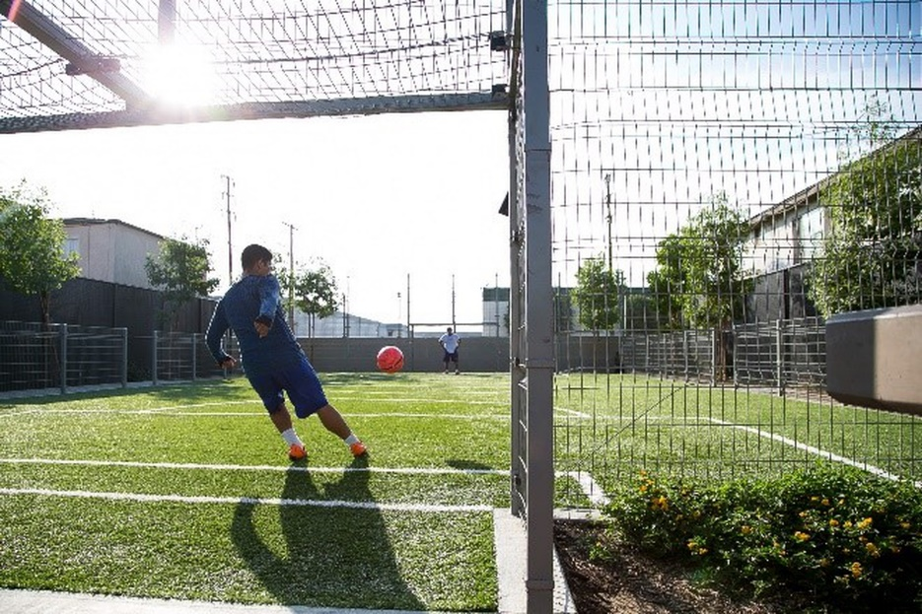
Benito Juarez Park. City of Maywood. SPP.
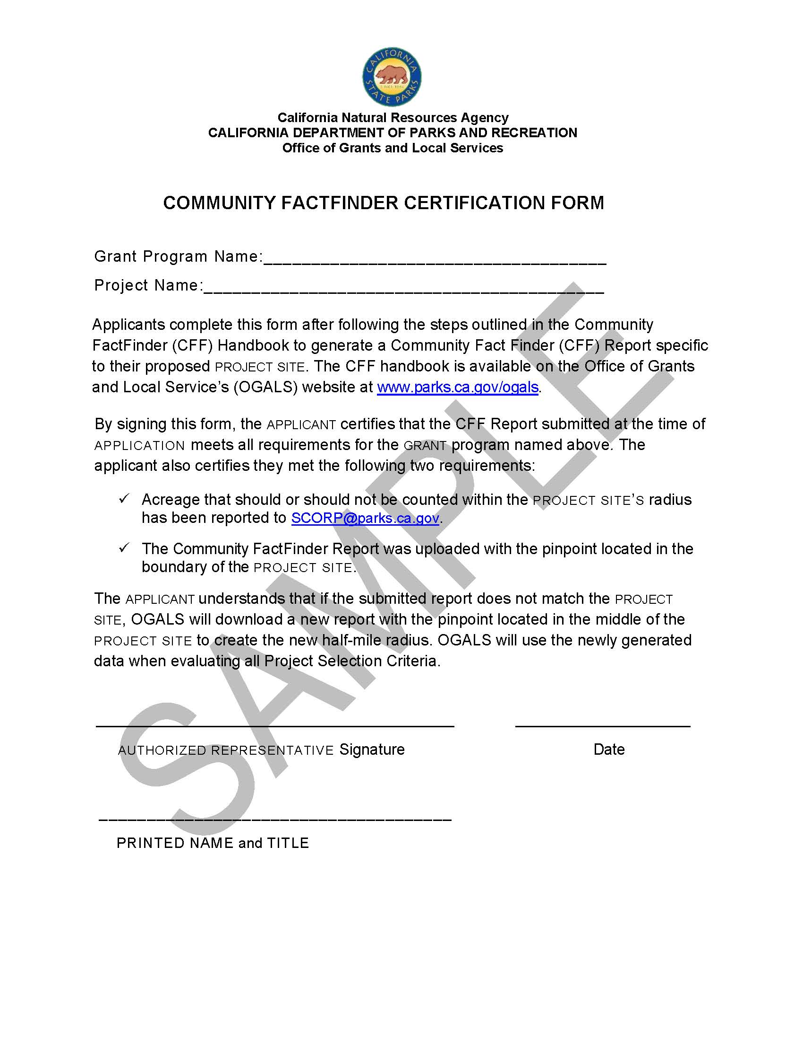

Checklist Item #4 - Authorizing Resolution Form
The Authorizing Resolution Form (DPR #XXX) template is available under FORMS at www.parks.ca.gov/spp.
The Authorizing Resolution serves three purposes:
- Demonstrates that the applicant’s Governing Body is aware of and understands all the terms of the contract.
- It provides confirmation that the applicant has the funding to complete the proposed project if the grant is awarded.
- Designates a position title, not an individual’s name, to represent the Governing Body on all matters regarding the application and project. This designated position is referred to as the authorized representative. All signatures required on documents should be the signature of the authorized representative, unless delegated. Submitted documents should be signed and scanned or digitally signed using an encrypted signature, such as Adobe’s Digital ID.
- Delegation requires the authorized representative to submit a letter (on letterhead) or email to OGALS identifying which positions have delegated authority to sign which documents.
The Authorizing Resolution Form may be reformatted to fit the agency’s letterhead or add additional signature lines. The language provided in the resolution must remain unchanged. Please be aware that changes to the language may require a CA Department of Parks and Recreation Legal Office review.
The time involved with the legal review process may delay application approval and could affect ogals’ ability to recommend the project for funding.
- The Authorizing Resolution, on the following page, is a fillable form located at www.parks.ca.gov/spp. Parentheses within the Authorizing Resolution must be filled out with the requested information.
- The project name on the Authorizing Resolution must match the project name on the project application Form (Checklist item #1).
The Authorizing Resolution must either be signed by the Clerk or have other evidence that it was adopted.

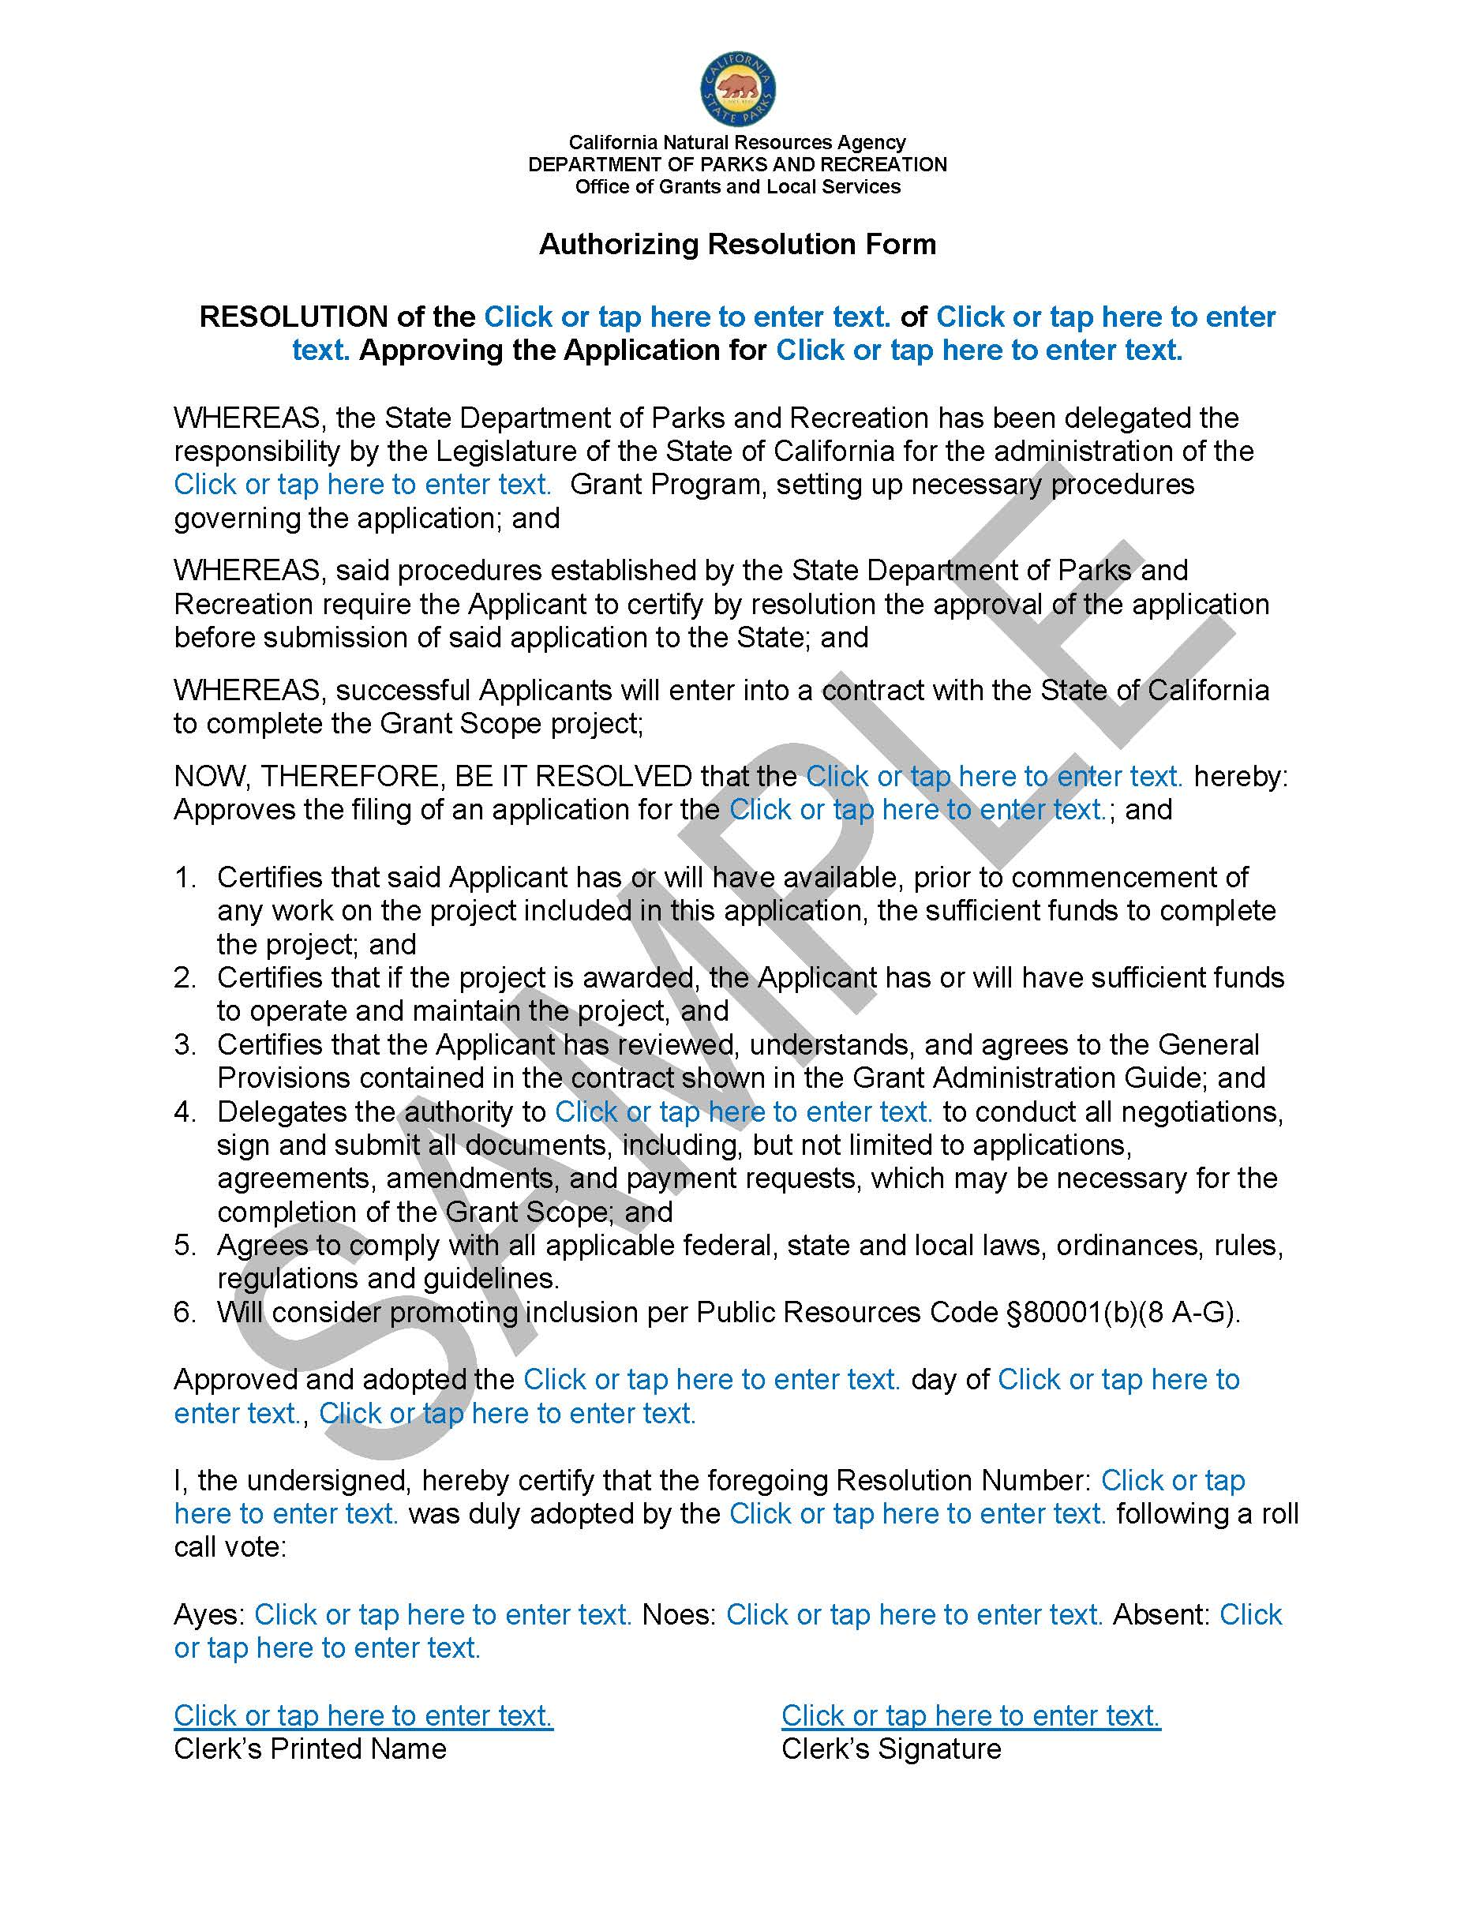

CHecklist Item #5.a, 5.B, and 5.C - Grant Scope/Cost Estimate Form, Indirect Cost Rate Form & Budget Narrative
5.A – Grant Scope Cost Estimate Form
The fillable grant scope/Cost Estimate Form (DPR #832C) is available under FORMS at www.parks.ca.gov/spp.
The Budget Narrative is completed using a Word document; directions are available under Technical Assistance Resources at www.parks.ca.gov/spp. applicants should include costs for certified conservation corps services and consider the Americans with Disabilities Act when preparing the grant scope /Cost Estimate & Budget Narrative.
Americans with Disabilities Act
Each recreation feature and major support amenity listed in the grant scope, and their related paths of travel from parking lots and roadsides, must be designed to accommodate persons with disabilities per compliance with the Americans with Disabilities Act of 1990 (42 U.S.C. sub section12101 et seq.).
The grant scope /Cost Estimate Form is used for the following purposes:
- Establishing the grant scope
  - recreation feature(s), major support amenity(ies) and minor support amenity(ies)
  - Provide a Cost Estimate for the project
- Establishing the indirect costs
- Creating a Budget Narrative for the project costs
  - Establishing the grant scope
The Grant Scope/Cost Estimate Form is used to establish the expected deliverables for project completion reimbursement by the SPP grant plus committed funds.
The requested grant amount cannot increase after the application deadline.
All recreation features and major support amenities proposed in the Project Selection Criteria section must be listed on this form and on the site plan (checklist item #13).
What to include on the form:
- All recreation features and major support amenities
  - To be eligible for grant payment(s), all recreation features and major support amenities must be included on the Grant Scope/Cost Estimate Form.
  - All reimbursement requests must be made before the end of the grant performance period.
- Only list the recreation features and major support amenities that will be completed before the end of the grant performance period.
Do not include future development phases that require additional fundraising beyond the grant plus committed funds. Limit the project to what can be completed with the grant plus committed funds.
For acquisition and development combination projects: a phase that develops a recreation feature on the acquired property must be open to the public before the end of the grant performance period.
Examples of recreation features and major support amenities.
    - Listing the Recreation Feature(s) and Major Support Amenity(s)
Each distinct recreation feature and major support amenity must be listed on its own line. applicants can use as many pages of the Grant Scope/Cost Estimate Form as needed. Label each page as Page 1, Page 2, Page 3, etc.
Use the following phrases to describe the type of work for each recreation feature and major support amenity:
- “Acquire approximately____” (provide acreage and associated parcel numbers that will be acquired). See definition of acquisition on page XX.
- “Construct a new____” (identify the new recreation feature or major support amenity that does not currently exist and include the specific type and number). Add “with lighting, shade, or fencing” if applicable.
- “renovate a____” (identify the existing recreation feature or major support amenity and include the specific type and number). See definition of renovation on page XX. Add “with lighting, shade, or fencing” if applicable.
Listing the type and number of recreation feature(s) or major support amenity(s): Identify the distinct type of recreation feature or major support amenity. List the specific number of recreation feature or major support amenities of the same type.
Examples of listed type and number of recreation feature(s) or major support amenity(s):
- Athletic Fields or Courts:
Specify, on separate lines, the type and number of each separate athletic field or court. Multi-use fields or courts should include the types of uses.
Example: Instead of “Construct new athletic courts” enter:
- “Construct two new full basketball courts with lighting”, “Construct a new futsal court with fencing”, “renovate four pickleball courts,”, etc.
- “Construct a multi-use field for soccer, field hockey, and cricket.” “Construct a multi-use court for volleyball, badminton, or kickball.”
- Play Areas:
Similar to sports courts and fields, play areas need to be specific to the amount of separate and distinct play areas.
Example: “Construct two new playground areas” if the project has two distinct and separate playground areas.
- Group Picnic Areas:
If a picnic/BBQ area is designed for the purpose of group gatherings, with multiple tables located near each other, identify the specific number of group picnic areas (not the number of tables and BBQ grills).
Example: “Construct three new group picnic/BBQ areas with shade structures.”
major support amenities include support facilities and support improvements that enhance the park or recreational experience.
- Support facilities — such as parking lots, restroom buildings, storage or maintenance buildings, snack shacks, and concession stands — must always be listed individually on the Grant Scope/Cost Estimate Form regardless of estimated cost.

- Support improvements located throughout the project — such as lighting, landscaping, benches, tables, signs, drinking fountains, bike racks, trash receptacles, pathways, fencing, and security cameras — are classified based on cost:
- Less than $50,000 = minor support amenities
- $50,000 or greater = major support amenities
major support amenities must be listed individually on the Grant Scope/Cost Estimate Form using descriptions such as:
- “Construct new lighting throughout the park.”
- “renovate landscaping throughout the park.”
- “Construct new benches and tables throughout the park.”
minor support amenities should not be listed separately on the Grant Scope/Cost Estimate Form. Instead, they should be included within the cost of the associated recreation feature or major support amenities.
  - Example: If the grant scope is “Construct a new playground,” related minor support amenities such as a drinking fountain next to the playground should be included within the playground cost and not listed separately. The construction of the new playground (recreation feature) is the expected grant scope deliverable for project completion.
  - The costs of minor support amenities are accepted as part of the construction of the new playground.
Providing a Cost Estimate on 5.B – Grant Scope/Cost Estimate Form
See the project costs charts starting on page 55 before creating a cost estimate.
- Lump sum cost: Provide the concept level estimated cost for each recreation feature and major support amenity. Fold all necessary costs into the related recreation feature(s) and major support amenity(s). Do not list costs such as demolition, site prep, grading, utilities, personnel, contingency, etc., as separate line items.
  - Contingency: Contingency costs can be built into the lump-sum cost estimate. It is understandable that actual costs may change during the grant performance period due to economic factors, supply chain issues, or other unforeseen circumstances. In most cases, a revised grant scope/Cost Estimate Form is not required when estimated costs fluctuate during the project.
- Pre-Construction Costs: No more than 25% of the grant amount may be spent on pre-construction costs.
- Check calculations: Make sure all costs add up correctly to the total project cost and that the formulas have not been changed or broken.
- Check consistency: The “total project cost” and the “Requested Grant Amount” on the Grant Scope/Cost Estimate Form must be consistent with checklist item #1 – project application Form and checklist item #6 - Funding Sources Form.
- Certification: The Grant Scope/Cost Estimate Form must be signed by the authorized representative.
- Indirect Cost: indirect costs are allowed costs for Proposition 4 (Climate Bond) grant projects. However, indirect costs are not required. Therefore, a grantee may choose to opt out of utilizing indirect costs for the grant project.
indirect costs are calculated as a percentage of the direct costs of the project. This percentage is called the indirect cost rate. The indirect cost rate is applied to certain types of direct costs, called the cost base, to calculate a project’s indirect costs. For Proposition 4 (Climate Bond) grants, food and beverages, fundraising, lobbying and entertainment may not be included in calculating indirect project costs.

5.B - Indirect Cost Rate Instructions
Introduction
indirect costs are overhead business expenses of the grantee’s fixed or ordinary operating costs (e.g., rent, mortgage payments, property taxes, utilities, office supplies). Food and beverages, fundraising, lobbying and entertainment may not be included in calculating the project’s indirect costs. Cost must be directly related to the project’s specific direct cost and scope of work. indirect costs are an allowable expense for Proposition 4 grant projects, but they are not required.
There are multiple accepted ways to calculate indirect costs. The chosen method must be supported by an accounting methodology following Generally Accepted Accounting Principles (GAAP). Calculate the indirect cost amount budgeted for the grant on the Grant Scope/Cost Estimate Form.
- indirect cost rate is a percentage of the project’s direct costs.
- The project’s indirect cost rate is applied to certain types of direct costs, called the cost base.
- applicant will select one indirect cost rate for the life of the grant performance period.
- The indirect cost Rate Form is a required document and must be submitted as part of the application packet.
- The applicant must maintain records to support the indirect cost rate and in the event that the project is audited.
Cost Base Example – Modified Total Direct Costs
An example of a cost base is the Modified Total Direct Costs (“MTDC”) used in federal grants (see 2 CFR 200.1). The chart below shows direct costs that are included and excluded in the MTDC base.
Included Direct Costs | Excluded Direct Costs
- Direct salaries and wages | - Equipment/fixtures
- Applicable fringe benefits | - Capital expenditures (Construction/Acquisition)
- Materials and supplies | - Charges for patient care
- Services | - Rental costs
- Travel | - Tuition remission
- Up to the first $50,000 of each | - Scholarships and fellowships
subaward. | - Participant support costs
 | - Portion of subawards in excess of $50,000

5.C - Budget Narrative
The purpose of this requirement is to evaluate how the applicant determined the total budget for their proposed project. This requirement can be completed by submitting either a Word or PDF document with their online application. Length of document must be sufficient to address all line items on the Grant Scope/Cost Estimate Form.
Provide a response to the following:
1. What source(s) did the applicant use to determine the total budget for their proposed project? For example, did the applicant utilize in-house staff or contractors to determine a reasonable requested amount for the lump sum cost of a recreation feature/Major Support Amenity?
2. What combined cost factors did the applicant consider for determining the total cost of each item listed on the Grant Scope/Cost Estimate Form? For example, what combined cost factors were included, such as item cost + shipping cost + construction cost + possible indirect or contingency costs for the total cost of a playground?
- California state construction projects typically include a contingency of 10% to 15% of the estimated construction cost to cover unforeseen expenses, design errors, inflation, and, in some cases, supplemental work.

Checklist ITem #6 - Funding Sources
The Funding Sources Form (DPR #832D) can be found at www.parks.ca.gov/spp under FORMS.
- Use the Funding Sources Form to list all funding sources by name and amount.
- List whether the funding source is state, local city or county, federal, or private.
- Source Changes: If any funding sources change during the application review process, a revised Funding Sources Form will be required.
- Loans: If the source is a loan, identify the type of loan. Be mindful of grant contract Provision N (language shown below copied from grant contract Provisions):
N. Use of Grant Monies
grantee shall not use any grant funds (including any portion thereof) for the purpose of making any leverage loan, pledge, promissory note or similar financial device or transaction, without: 1) the prior written approval of the state; and 2) any financial or legal interests created by any such leverage loan, pledge, promissory note or similar financial device or transaction in the project property shall be completely subordinated to this contract through a Subordination Agreement provided and approved by the State of California, signed by all parties involved in the transaction, and recorded in the County Records against the fee title of the project property.
- Date Committed – list dates when each funding source was committed to the project. All additional funds must be secured within four months of the application deadline. See the definition for committed funds.
- Project Selection Criteria #6: If funding is provided by a partner, list the source and amount on the Funding Sources Form.
- Check Consistency: The total project cost listed at the bottom of the Funding Sources Form must equal the estimated total project cost listed on the application Form and at the bottom of the grant scope/Cost Estimate Form.
- Certification: The Funding Sources Form must be signed by the authorized representative.
Download the Funding Source/Match Form at www.parks.ca.gov/spp under FORMS.
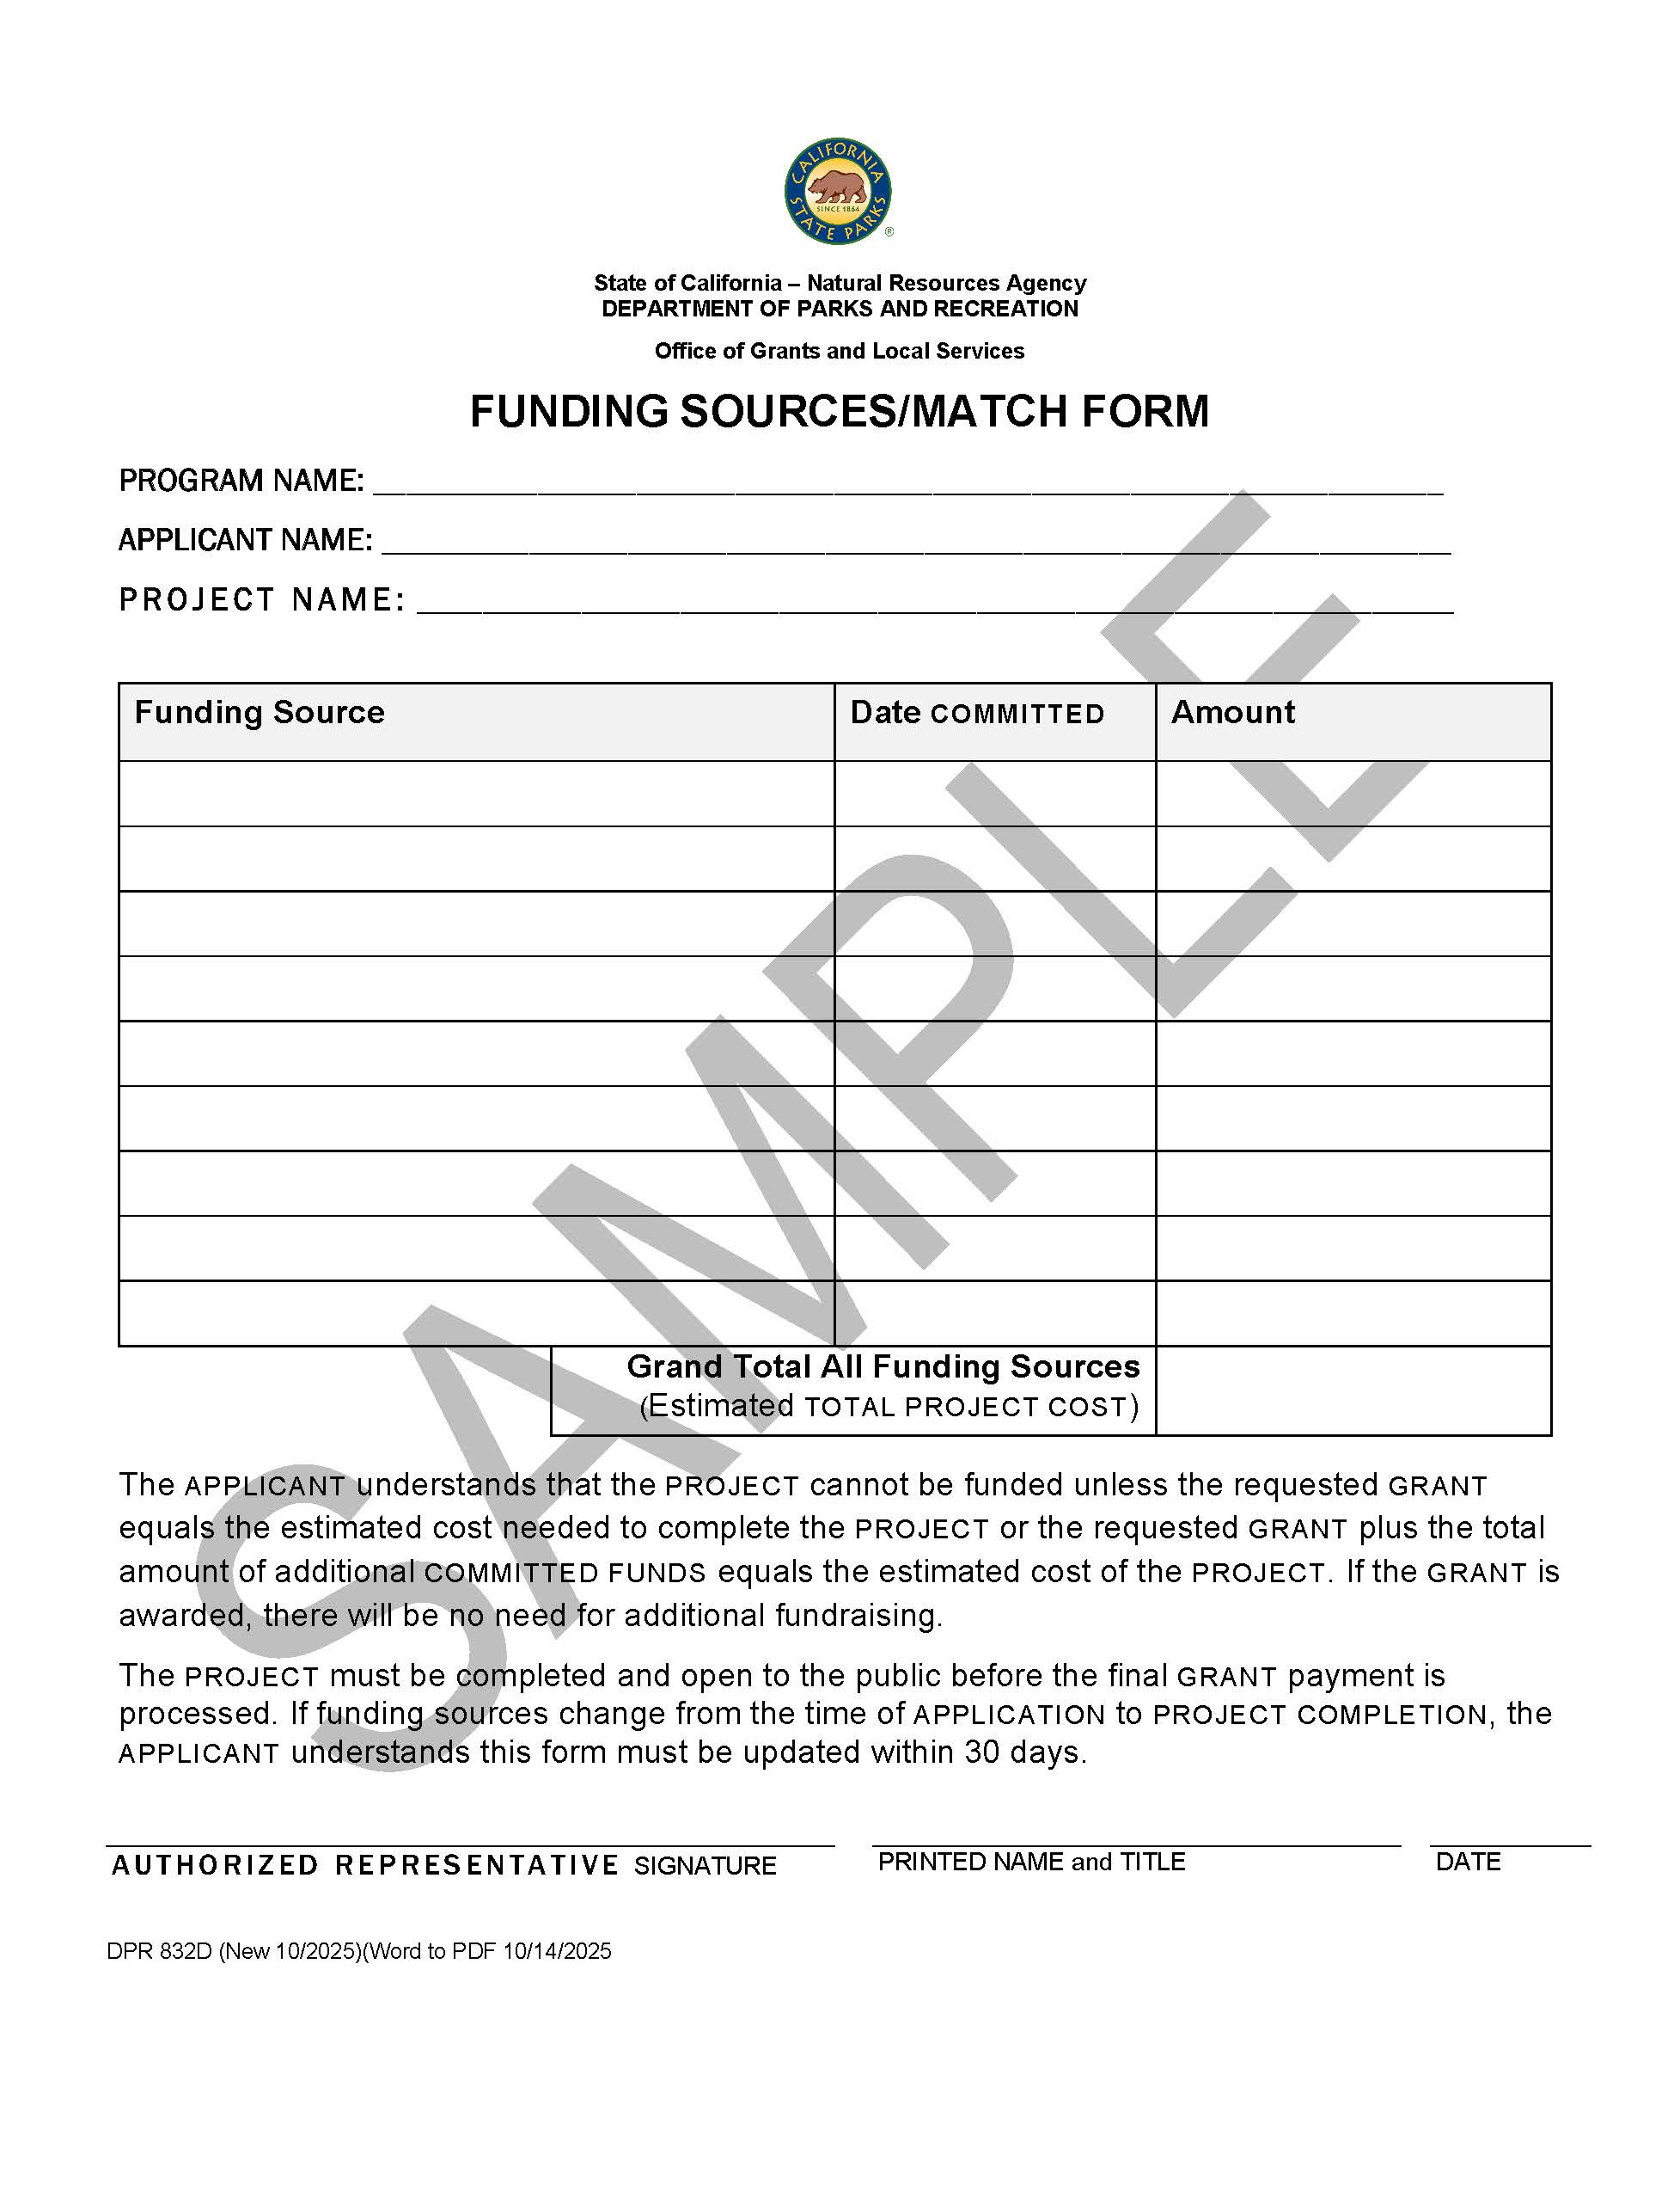

Checklist Item #7 - Project Timeline Form
The Project Timeline Form (DPR #832B) can be found at www.parks.ca.gov/spp under FORMS.
The purpose of the project timeline requirement is to encourage applicants to discuss the project and create a timeline with each agency that will have approval responsibilities. For example: If another agency is responsible for approving a construction permit, the estimated time for obtaining the permit, along with the agency’s name and a representative’s contact information, should be included in this timeline.
- Add any additional task requirements that are necessary to complete the project.
- For each task, identify the agency contact who reviewed the timeline and agreed that the estimated time set aside to complete the task is reasonable, assuming conditions remain unchanged. If an item is complete and without issues then in the right two columns, write “Item Complete”.
- Not all tasks in the form are required to be completed by the time of application; however, the form serves as evidence that applicants are aware of potential time periods for all project tasks.
- For the last row that shows: “30 years of operation and maintenance for public use,” use the appropriation date as the start date and the end date should be 30 years after the start date. The appropriation date is located at www.parks.ca.gov/spp.
- The project Timeline Form must be signed by the authorized representative.
Format Notes:
A different format may be used. However, the following columns must remain in the same order:
- “Tasks”
- “Start Date Month/Year”
- “End Date Month/Year”
- “Lead Agency…contact information”
- “Notes about potential delays/issues”
As stated in the top left corner of the project Timeline Form, the list of tasks may be adjusted or reorganized based on each unique project.
Download the Project Timeline Form at www.parks.ca.gov/spp under FORMS.
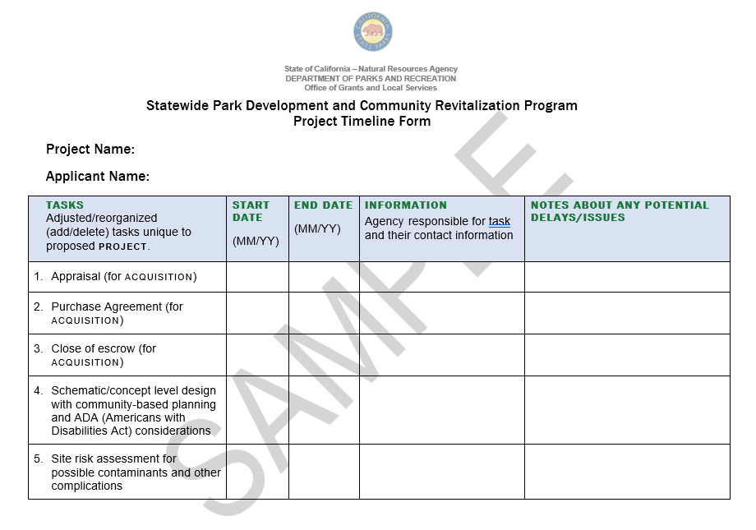

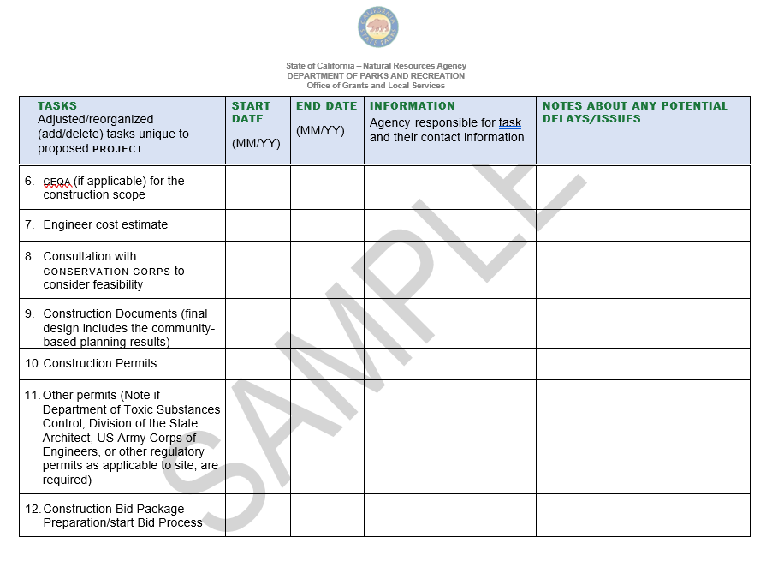
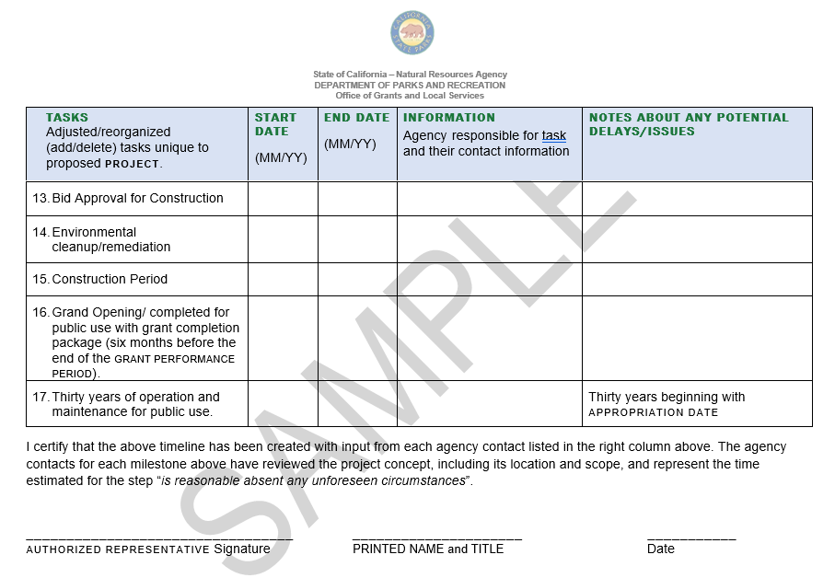

Checklist item #8 - applicant Capacity
The purpose of this requirement is to evaluate the applicant’s capacity to achieve project completion, as well as 30 years of adequate operation and maintenance for public use beginning with the appropriation date.
ogals conducts an analysis of the applicant’s :
- experience or capacity for project completion,
- long-term operation and maintenance based on the project’s design, and
- previous grant and operational experience.
applicants must consider:
- Projected monthly/annual operation and maintenance costs which include, but are not limited to, water and energy utilities, staffing, repairs, etc.
- Projected annual cost compared to projected long-term funding sources for operation and maintenance. Another entity can provide operation and maintenance services. However, the OGALS contract requires the grantee to ensure the park is operated and maintained and open to the public for thirty years, beginning with the appropriation date.
Provide a response to the following:
- Describe up to three parks or other construction projects completed within the last ten years by the applicant. Include:
- project address
- scope of work
- total project cost
- funding sources
- start date, and date of completion
- Provide a chart of the operation and maintenance budget breakdown showing the monthly and annual total expected cost to operate and maintain this proposed project (include utilities, routine repairs/upkeep, and staffing costs).
- What are the planned funding sources to operate and maintain the proposed project?
- Provide the weblink for a list of parks and facilities the applicant currently oversees. If a website is not available, provide the list in this response.

Checklist Item #9 - PROJECT SITE Status: Owned, Acquisition, Lease and turn-key agreementS
The purpose of this requirement is to ensure the applicant will have site control that allows for project completion. A project may have more than one status involving multiple parcels of land.
For example: An applicant owns part of the project site and is proposing to acquire an adjacent parcel of land. In this case, the applicant would provide documents for status #1 and status #2 below.
Applicants must provide applicable items below to show planned project site control:
- Provide #1 below if the land is already owned by the applicant.
- Provide #2 below if the applicant is proposing an acquisition to become the landowner.
- Provide #3 below if the land is not owned by the applicant and will have a lease agreement with the landowner (e.g., school district, utility owner, etc.).
- Provide #4 below if the land is not owned by the applicant and will do a “turn-key” agreement. The applicant will complete the project and then transfer Operation and Maintenance requirements to an eligible grant landowner. OGALS must approve the eligible grant landowner.
Status #1: If the project site is owned in fee simple by the applicant:
- Provide a copy of the deed, deed recordation number, or title report, or a current county assessor’s parcel map showing the applicant owns the land.
Status #2: If the applicant is proposing an acquisition to become the landowner:
- Provide a county assessor’s parcel map showing the parcel(s) to be acquired that match the parcel numbers listed on the Grant Scope/Cost Estimate Form.
- Provide a letter from the landowner(s) indicating the intent to sell the property subject to grant award. The letter does not need to include legally binding language or provide a document indicating the land is publicly for sale or that it is a donation.
acquisition of land from a willing seller is eligible for reimbursement. The following reimbursement restrictions apply:
- acquisition costs associated with condemnation or eminent domain are not eligible for reimbursement.
- The land’s sale price may be up to, but cannot exceed, the appraised fair market value. State funds may not be used in part or whole to acquire property above the appraised value.
OGALS requires all grantees to provide an appraisal, dated within 12 months of escrow opening, establishing the fair market value of the property and a separate appraisal review. The appraisal review must be conducted by an independent third-party AG-rated appraiser certified by the California Office of Real Estate Appraisers, stating the appraisal was completed using acceptable valuation methods. California Bureau of Real Estate Appraisers provides a list of AG level appraisers. This list can be found at www.parks.ca.gov/spp under Technical Assistance Links – Checklist #10 – Project Site Ownership, Acquisition, or Lease.
The eligible costs Chart on page XX includes appraisals. Appraisal costs incurred during the grant performance period can be reimbursed.
If the project is awarded, and the grantee is acquiring or owns the project land in fee simple, a Deed Restriction must be recorded on the title of the property before ogals will approve any grant payments except an advance into escrow and pre-acquisition costs. A Deed Restriction restricts the title to the property, safeguarding the property for purposes consistent with the grant for the duration of the contract performance period.
Status #3 and 4: Information about “Lease Agreement and turn-key Agreements” is available under at www.parks.ca.gov/spp under Land Tenure.
- Lease agreements are completed when an applicant is proposing to construct, operate and maintain a project on land owned by a separate public agency or utility district.
  - The land must be owned by a public agency or utility, and the agreement must be approved by DPR.
- Turn-Key agreements occur when an applicant is proposing to construct a project, and upon project completion, and with approval by the State, transfer the project and contract obligations to the landowner. The landowner would then become responsible for operation and maintenance of the project for public use during the remainder of the 30-year contract performance period.
  - The landowner must be an eligible applicant. See page XX for list of eligible applicants.

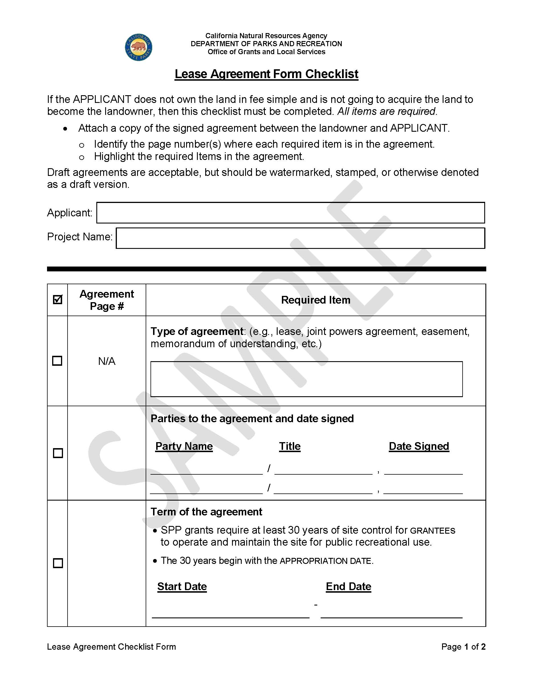

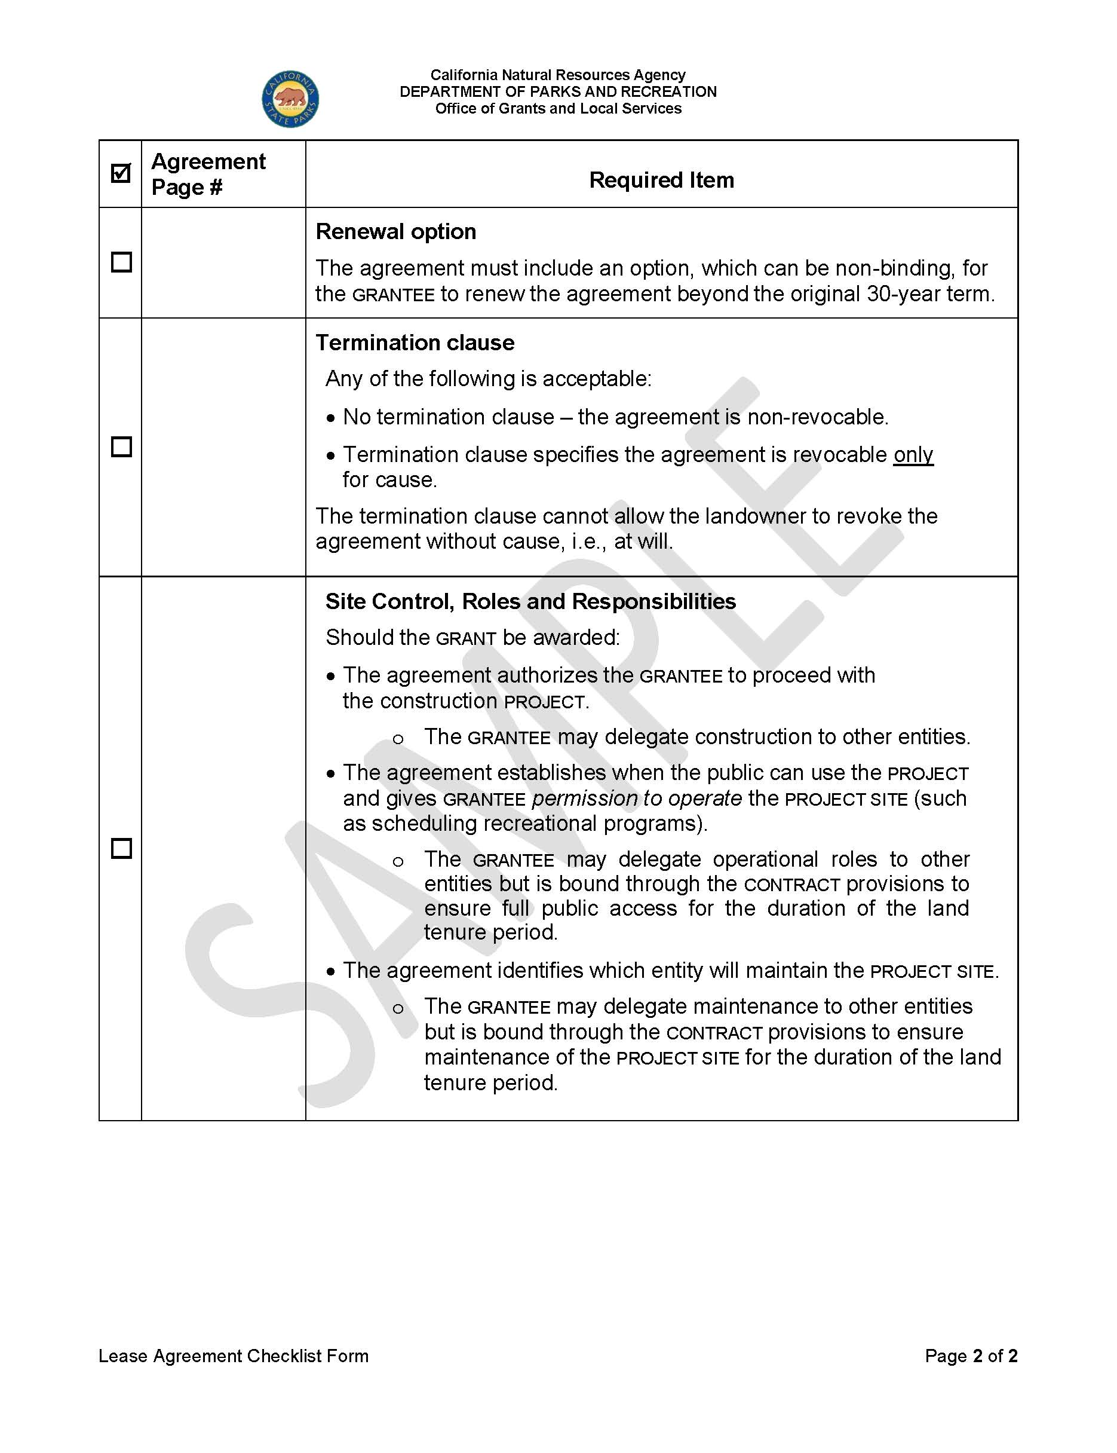

Checklist Item #10 - concept level site plan
Provide a legible site plan drawing showing where each recreation feature and major support amenity will be located within the park.
- Only identify the recreation features and major support amenities that are listed on the grant scope/Cost Estimate Form and mentioned in Project Selection Criteria #4. Differentiate or shade out any pre-existing or future phase items that will not be part of the project proposal.
  - major support amenities, with an estimated cost of more than $50,000, such as exterior metal fencing, security cameras, or landscaping should be identified on the site plan.
- Provide a legend/key to visually explain all symbols used on the concept level site plan. Include a north arrow and street names along the project site.
- If the grant scope includes new construction or expansion of any building(s), provide both of the following:
- Identify the proposed percentage of indoor versus outdoor space; no more than 50% of the overall park can be designated for indoor use through the project.
- Identify the total square footage of the building, note the function, and approximate square footage of each space designated for recreation.
  - At least 75% of the building’s square footage must be designed for recreation. Lobby areas, hallways, meeting rooms, office space, storage, and restrooms do not count as square footage designed for recreation. For example, a community center could be designed as: 75% of space for recreation, 10% restrooms, 5% lobby, 5% storage, and 5% offices.
Note: 1-2 above do not apply if the renovation is not changing the layout of the building or for new or existing stand-alone restrooms/snack shacks.

Checklist Item #11 - Photos and Copyright Agreement Form
The Statewide Park and Community Revitalization Program (SPP) is the largest park- related grant program in California's history. To report this program's legacy, each project will be featured online and viewed by local agencies, the California State Legislature, other states, and the public. The Copyright License Agreement allows the State of California’s use of photographs and videos in any publications, websites, promotions, etc. applicants should make residents aware of this form.
OGALS may request copies of your internal consent forms at any time. It is important to note that grantees' internal visual media consent forms must include language notifying individuals that their image may be shared with partnering agencies (e.g. California Department of Parks and Recreation), to ensure clear understanding of how the images may be used.
The Copyright License Agreement Form (DPR #992A) is available at www.parks.ca.gov/spp under FORMS.
Project Site Photographs
Photographs provide reviewers with a better understanding of the project site and the community. Items 1-2 below, may be used to report the “Before and After” accomplishments of grantees. ogals may highlight awarded projects at parks for California website located at https://www.parksforcalifornia.org/projects/.
- Provide high quality JPEG (5MB or larger) photographs of the project site and its surrounding area. Include captions to orientate the reviewer.
- Submit at least one panoramic photograph that captures as much of the project site as possible with a background point of reference for potential “before and after” photographs.
  - Drone photographs and videos, where permitted, may be submitted.
Community-Based Planning Photos
- Provide high quality JPEG (5MB or larger) photographs of various community-based planning meetings, per Project Selection Criteria #5, on page XX.
- Photographs of residents actively providing ideas are preferred. Photographs do not need to include every resident that participated. Include a photograph caption that provides the date and location of the meeting.
2. Provide one signed Copyright License Agreement that will cover all photographs and videos. The Copyright License Agreement does not need to be signed by the authorized representative and can be signed by any applicant staff member who can certify that internal visual media consent forms were collected, including language notifying individuals that their image may be shared with partnering agencies.

Checklist Item #12 - Project Location Map
The purpose of the project location map is to provide a visual map of the project site area.
Include on the map:
- Highway and street access to the project site.
Ensure the project site is clearly shown and identified on the map by clearly outlining the project boundary using a bold line.
Necessary geographical landmarks and buildings should be identified to help locate the project site
If a project site has an address and is nearby, for example, Interstate 405 and State Route 99 highway, the visual map of the project site area should include both freeways.
project sites that use Global Positioning System (gps) coordinates instead of an address must include necessary geographical landmarks and buildings in the visual map of the project site area.
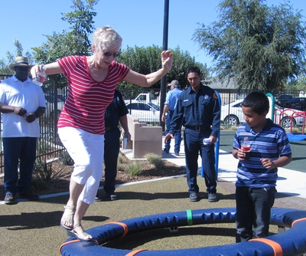
Avenal Neighborhood Park, City of Avenal. SPP.

Checklist item #13 - nonprofit application Requirements
This section is for nonprofit applicants only.
See the Nonprofit Guidance Information Booklet for additional Checklist Item #13 and general nonprofit guidance. This booklet is available at www.parks.ca.gov/spp under Checklist #13 - Nonprofit Guidance Information Booklet.
nonprofits must have an approved tax-exempt status from both state and federal governments to do business in California. nonprofits with a revoked or suspended status are not eligible for grant awards.
nonprofits are required to provide items 1-5 below:
- IRS (Internal Revenue Service) Letter of Determination indicating approved 501 (C)(3) tax-exempt status
- IRS Form 990 tax filings for the last two years with forms showing signature page with appropriate signature(s) and filing date. ogals does not accept draft copies of 990 Forms. One, or a combination of, the following three forms are acceptable:
- 990 (first two pages)
- 990-EZ (first four pages)
- 990-N (e-Postcard): nonprofits who filed an e-postcard must provide a signed copy of their Annual Treasurer’s Report (FORM CT-TR-1) for the corresponding year. E-postcards do not have a signature page.
- California Franchise Tax Board (FTB) Self-Service Entity Status Letter
- Must be in good standing and show 501 (C)(3) exempt status
- Must not be on the Automatic Revocation of Exemption list
- Attorney Generals’ Registry of Charities and Fundraisers - Annual Renewal Fee Report (FORM RFF-1): If “yes” was marked on any of the questions on the form, attach the provided explanation.
- Registry of Charities and Fundraisers - Registrant Details page showing “Approved” or “Exempt” Status.
- If the “Renewal Due/Exp. Date” is going to expire within four months after the application deadline, ogals may request a copy of the submitted renewal prior to grant award.
- If the Registrant Details page shows an expired “Renewal Due/Exp. Date”, then provide a copy of either of the following:
- Signed first page of the upcoming Annual Registration Renewal Fee Report filed to the Attorney General of California (FORM RFF-1).
OR
- If the nonprofit organization has filed Form 8868 for an extension with the IRS, provide their issued letter of approved extension.
IRS EXEMPTION LETTER
nonprofits may include an Exemption Letter in place of their Annual Registration Renewal Fee Report. However, an Exemption Letter is not necessary if the nonprofit’s Registry of Charities and Fundraisers’ Registrant Detail Page Says “Exempt.”
NEWLY FORMED NONPROFITS
nonprofits with less than two years of incorporation may not have all the requested documents available. ogals requires nonprofits to provide a letter of explanation for each missing item and their plan for correcting each missing item.
ogals reserves the right to request the following four additional documents:
- Articles of Incorporation
- Mission statement
- Balance sheet showing assets and liabilities for most recent fiscal year
- Income statement showing revenue and expenditure projections for the next calendar or fiscal year (using the Annual Treasurer’s Report FORM CT-TR-1)
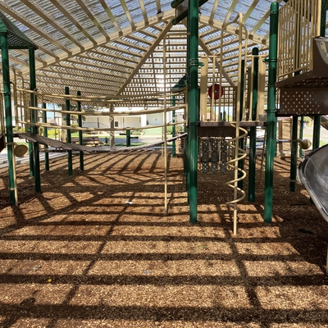
Houlihan Park Renovation. County of Merced. SPP.

CHECKLIST ITEM #14 - CONSERVATION CORPS Consultation Process)
There are two certified conservation corps the applicant can use to earn points:
- California conservation corps (CCC) and
- California Association of Local conservation corps (CALCC)
applicants who choose to complete this process are only required to work with one above-identified certified Corps.
The Certified Corps Consultation website link is available at www.parks.ca.gov/spp under Technical Assistance Links – Conservation Corps.
Public Resources Code, Division 5, Chapter 3.3, §5646(c) states:
The project will enhance workforce development and employment opportunities, utilize members of the California conservation corps or certified conservation corps, if available, or accommodate outdoor learning opportunities for school pupils or at-risk youth in the service area.
It is important for applicants to create a detailed project work plan that includes all cost estimates prior to application deadline to accurately reflect request amounts on Checklist Item #5.A - Grant Scope/Cost Estimate Form & 5.B - Budget Narrative. The grant request amount cannot be changed after application deadline; the applicant cannot request additional funding.
Steps 1 - 4 below should be used by the applicant to confirm their completion of the certified Corps consultation process and calculate a budget for their services. OGALS highly recommends submitting consultation requests at least 30 days prior to the application deadline.
- applicants visit the CCC webpage to fill out the Corps Consultation Form. Applicants should be prepared to submit detailed project information. Grant program questions include the following:
- Project Funding Type: Climate Bond – Prop 4
- Department Administering Grant Program: DPR
- Name of Grant Program: Statewide Park Program
- Applicants will have to provide both an Application Deadline and an anticipated Grant Award Date. This information is provided on the SPP Program Timeline at www.parks.ca.gov/spp.
After the form is submitted, applicants will receive an email confirmation with the subject line: “We have received your request for Corps Consultation.” The date stamp on the confirmation email must be before application Deadline to earn points for using one of the Certified Corps.
- The CCC and CALCC review projects and notify applicants within 14 business days by providing a Corps Consultation Review Document. applicants should receive a response from both Corps stating either:
  - Yes, it is feasible to work on the project.
    - If enough information is provided on the project, the “yes” response will include a budget.
    - If not enough information is provided on the project, the “yes” response will not include a budget.
  - No, it is not feasible to work on the project.
- applicant must submit the Corps Consultation Review Document response received from the Corps with their grant application. This submission serves as evidence that consultation with at least one certified conservation corps was completed.
  - “Yes” feasibility letters must include a budget. “Yes” letters without a budget are considered incomplete. applicants would need to reach out to the Corps to complete the consultation process and request a copy of the budget in writing.
  - “No” feasibility letters do not need to include a budget.
  - If an applicant declines all aspects of services offered by the certified conservation corps, then zero points are earned – see Project Selection Criteria #6(C).
- Applicants who do not receive a completed Corps Consultation Review Document prior to application Deadline must submit a placeholder. The email confirmation with the subject: “We have received your request for Corps Consultation” acts as the place holder.
- The date stamp on the confirmation email must be before application Deadline. Emails with date stamps after the application Deadline will earn zero points.
- Once the applicant receives a completed Corps Consultation Review Document, they should reach out to their assigned project officer for submission details.
Certified CONSERVATION Corps Consultation Website
The Certified conservation corps Consultation website link is available at www.parks.ca.gov/spp under Technical Assistance Links – Conservation Corps.

project Costs

eligible costs
This section provides rules and examples of eligible costs for acquisition and development.
acquisition Costs
The following table provides examples of eligible costs for acquisition.
ACQUISITION COSTS  Up to 100% of Grant Amount | ELIGIBLE ACQUISTION COST EXAMPLE
Purchase price of the property and other activities necessary to complete the  acquisition. | - Appraisals (fair market value), surveys  - Preliminary title reports  - Title reports, title insurance fees  - Escrow fees and purchase price  - Relocation costs: costs resulting in displacement  of tenants (not willing sellers or grantees) pursuant to Government Code §7260 – 7277.  - If the grant is not paying for relocation costs, the grantee must ensure that the willing seller is paying displaced tenants in compliance with Government Code §7260 – 7277.  - Employee services: see accounting rules  in the grant administration guide.  - project/grant administration and accounting

development COSTS
development includes pre-construction costs and construction costs.
- pre-construction is the phase that includes planning, design, construction documents, and permits necessary before construction can begin. No more than 25% of the grant amount may be spent on pre-construction costs.

- construction costs starts:
- After the pre-construction phase has concluded and ground-breaking construction activities such as site preparation, grading, or gutting begins.
PRE-CONSTRUCTION COSTS  Maximum 25% of grant amount | ELIGIBLE PRE-CONSTRUCTION COSTS EXAMPLES
Costs incurred during the planning, design, and permitting phase of the project, before construction (ground-breaking) begins such as site preparation, grading, or gutting. | - Community-based planning meetings, focus groups, and design workshop costs. May include multi-lingual translation, materials etc.  - Plans, specifications, construction documents, and cost estimates  - Permits  - CEQA  - SITES Certification or LEED Certification  - Premiums on hazard and liability insurance to cover personnel or property  - Fidelity bond premium cost  - Bid preparation and packages  - Employee services: see accounting rules for  employee services explained in the grant administration guide.  - project/grant administration (excluding grant writing) and accounting.  - indirect costs
The following table provides examples of eligible pre-construction costs.
construction COSTS  (Up to 100% of grant Amount) | ELIGIBLE construction COSTS EXamples
Costs incurred during the construction phase of the project and begin when ground-breaking construction activities start, such as site preparation, grading, or gutting.  Rental rates published by the California Department of Transportation may be used as a guide for renting equipment and charging for the use of equipment already owned by the grantee. | - Site preparation, grading, gutting, demolition  - Foundation work  - Purchase and installation of permanent equipment: playground equipment, benches, signs, display boards, sound systems, AV equipment, etc.  - Construction supplies and materials: may be drawn from central stock if claimed costs are no higher than supplies or materials purchased elsewhere.  - Construction equipment owned by the grantee may be charged to the grant for each use. For audit purposes, a report or source document must describe the work performed, indicate hours used, relate the use to the grant scope, and must be signed by the operator or supervisor.  - Construction equipment rented or purchased by grantee: equipment may be rented or purchased, whichever is the most economical use of grant funds. For purchased equipment, the grant will pay for the rental price equivalent in proportion to the time the purchased equipment is used on the grant scope. The grant will pay for the total cost of the equipment if the purchase price is less than the rental price equivalent. Funds earned by the grantee from the sale of equipment purchased with the grant must be spent on the project.  - Construction management: including site inspections, scheduling mobilization, directing equipment, materials, and construction personnel.  - Employee services: see accounting rules for employee services explained in the grant administration guide.  - project/grant administration & accounting  - Miscellaneous costs: other costs incurred during the construction phase such as transporting materials, equipment, personnel, communications, certified conservation corps, and landscape establishment periods.  - indirect costs
The following table provides examples of eligible construction costs.

Ineligible Costs
grantees who are unsure if their proposed cost(s) are eligible or ineligible should contact their assigned Competitive Team Project Officer for assistance.
ineligible costs | EXamples of ineligible costs
Cannot be charged to the grant. | - Outside parks/project site boundaries: streets, traffic lights, or other infrastructure not located within the park/project site.  - Outside the grant performance period: costs incurred before or after the grant performance period.  - projects imposed on an applicant through legal mitigation  - Fundraising  - Food and beverages  - Grant Writing  - Operation and Maintenance, equipment  - Moveable recreation features and support amenities  - Consumable supplies (toilet paper, paper towels, etc.)  - Out-of-state travel  - Acquisitions where purchase price is greater than appraised fair market value, even if the applicant is willing to pay the difference.  - Costs for land acquired through eminent domain or condemnation  - Record keeping discrepancies:  - Charging employee services without documentation of actual time spent on the project  - Lack of source documents (e.g., no evidence of invoices, bid process, payment receipts, etc.)  - See grant administration guide Accounting Requirements for additional guidance.
The following table provides examples of ineligible costs.

Appendices

Technical Assistance Resources
Technical assistance is available to applicants outside of this application guide. Additional technical assistance resources, including documents, forms, contacts, and program history are located at www.parks.ca.gov/spp.

ogals’ Competitive Review Team has gained experience through reviewing 1,827 statewide applications requesting $7.69 billion through SPP ROUNDS 1-4.
To ensure a fair process, ogals’ Competitive Review Team provides all applicants with consistent and accurate guidance. All statewide applicants are encouraged to access the following:
application Workshops
For each round, application Workshops will be offered. ogals’ Competitive Review Team will provide a page-by-page review of this application Guide. Each workshop is identical going through the application Guide page by page. The purpose of the workshop is to provide immersive and interactive education and training for completing a competitive application. Dates and times for the workshops will be posted at www.parks.ca.gov/spp.
Access to the Competitive Review Team
ogals’ Competitive Review Team strives to provide outstanding customer service to all applicants as the program experts. applicants are encouraged to call, email, or schedule meetings when guidance is needed. Contact the Competitive Review Project Officer assigned to the county where the project is located. To access this list by county, go to www.parks.ca.gov/spp and click on “Contact Us.”
SPP Application Guide
This guide includes a Technical Assistance section with additional Project Selection Criteria guidance and examples about how to be competitive.
Assistance with Incomplete application Documents
ogals may contact applicants to explain any correction needed. ogals does not automatically disqualify an application if a document is incomplete or needs correction except for the Project Selection Criteria.
ogals’ Competitive Review Team can also preview documents, excluding Checklist Item #2 – Project Selection Criteria, before the application deadline.

Strengths and Weaknesses
applicants who do not receive a grant award can request “Strengths and Weaknesses” feedback based on Checklist List Item #2 - Project Selection Criteria after grant award announcement. This feedback is useful to applicants if another round of funding is available or for other grant applications.
Grant Administration Workshop
applicants who receive a grant award are required to attend a mandatory grant administration workshop. During the workshop, ogals and DPR auditors will provide an in-depth review of the grant administration guide that explains the requirements and forms necessary for administration. ogals Grant Administration Team will be available to answer administrative questions through project completion.
California Environmental Quality Act (CEQA)
The California Environmental Quality Act (CEQA), codified in Public Resources Code §21000 et seq. and Title 14 of the California Code of Regulations §15000 et seq., establishes policies and procedures requiring agencies to identify, disclose, and, where feasible, reduce significant impacts to environmental and historical resources that may result from a proposed project.
If awarded SPP grant funding, the grantee, as the Lead Agency, is responsible for complying with all applicable CEQA requirements. Effective July 1, 2025, Public Resources Code §21080.57 established a CEQA exemption for eligible public park and non-motorized recreational trail projects funded under the Safe Drinking Water, Wildfire Prevention, Drought Preparedness, and Clean Air Bond Act of 2024 (Proposition 4).
The grantee is responsible for determining whether the project qualifies for the exemption or whether additional environmental review is required, as applicable. Additional CEQA compliance information is available at Statewide Park Program Grant Administration Resources.

Technical Assistance for Project Selection Criteria #1-10 (Checklist Item #2)

project Selection Criteria responses must be completed and submitted by the application deadline. This section uses guidance captured over the past rounds of the Statewide Park Program to assist applicants in creating a competitive project application.
Pages XX-XX provide examples and advice for each of the ten Project Selection Criteria.

Project Selection Criteria #1-10 Guidance
PROJECT SELECTION CRITERIA #1-3 pages. XX-XX
For applications to be eligible the community within proximity of the project site must meet one of the following conditions based on the California State Parks Community FactFinder Report:
- A ratio of less than three acres of park space per 1,000 residents. See Project Selection Criteria #1.
OR
- Is below the median household income threshold, which means it is a disadvantaged community as defined by subdivision (g) of § 75005 of the Public Resources Code. See Project Selection Criteria #2(A).
OR
- Within proximity to a climate vulnerability(ies) as defined by Division 50 Safe Drinking Water, Wildfire Prevention, Drought Preparedness, and Clean Air Bond Act of 2024 subdivision (b) of § 94010 of the Public Resources Code. See Project Selection Criteria #3.
Purpose of the Community FactFinder:
The use of the half-mile radius helps steer applicants towards placing projects in areas that best meet the program’s highest priority. The Community FactFinder’s half-mile radius uniformly quantifies the ratio of park space per 1,000 residents, number of residents below poverty, median household income, and climate vulnerabilities within proximity to projects using consistent data available statewide. If the radius was larger, it could encompass higher income areas, or greater parks acreage areas, which would disadvantage or disqualify many statewide applications.
- It is understood that some PROJECTS may attract visitors who live outside the half-mile radius and are able to travel from greater distances to the proposed project site. This may be described in Project Selection Criteria #10(A) and #10(B) on page XX.
- Describe challenges not captured by the Community FactFinder in Criteria #10(A).
How to select a competitive project site:
A Community FactFinder Handbook and video tutorial available at www.parks.ca.gov/spp includes visual examples and tips to select a competitive origin of the half-mile radius. Review (A) through (C) below, before submitting the final Community FactFinder Report.
- A new Community FactFinder Report must be created for this round.
- The black pin-tip is located in or on the proposed park’s boundary.
- The response to Project Selection Criteria #1- #3, submitted with the application, matches the Community FactFinder Report.
PROJECT SELECTION CRITERIA #4 - TYPE OF PROJECT, pages. XX-XX
For the application to be eligible, the proposed project must create at least one new recreation opportunity.
new parks
- Qualifies as a new park: Land zoned or designated to become a park, but not yet developed and open to the public prior to the current round’s SPP application due date.
- Does not qualify as a new park: Land developed and open to the public as a park or adjacent to an existing park before the SPP application due date.
  - If there is an existing park next to or across the street from the project, regardless of which agency owns the existing park, the project will qualify as an expansion.
- In built-out communities, a new park can be created by acquiring and demolishing a blighted building, or a street can be vacated and permanently redeveloped into a park.
RENOVATE EXISTING PARKS
The project must add or renovate at least one recreation feature. Examples of recreation features are listed on page XX. If there is a combination of renovation and new recreation features, make sure that the list is consistent with the Checklist Item #5.A - Grant Scope/Cost Estimate Form.
EXPAND EXISTING PARKS
- To expand an existing park, the project will acquire or develop land that is currently not part of the adjacent existing park boundary. This includes adding new acreage of park space that is easily accessible next to or across the street from an existing park, regardless of which agency owns the existing park.
- If a project will expand an existing park, the application has the option but is not required to also improve the existing park area. The application will qualify, and score as expand an existing park for this criterion.
- If an EXPANSION is proposed to increase the PARK boundary, provide an explanation about the current use and ownership of the EXPANSION property.
Applicants who will include a community center or gymnasium building in their project must also meet the following requirements:
- If the project will create a new, or increase the square footage of, an existing recreation building, at least half of the entire park must be designated for outdoor recreation and open space.
- The intent of this program is to create, expand, or improve parks. Community centers not in, or adjacent to a park, are ineligible.
  - Improving an existing community center that is not in a park is ineligible.
  - The construction of a new community center that is not part of a new park, or next to an existing park, or in an existing park, is ineligible.
PROJECT SELECTION CRITERIA #5 - COMMUNITY-BASED PLANNING
Project Selection Criteria #5(A), page XX
Review the “Designing Parks Using Community-Based Planning” document for additional insights and guidance for Project Selection Criteria #5(A). This document is available under Technical Assistance Resources at www.parks.ca.gov/spp.
Effective, highly used and safe parks are designed using significant community input. applicants are encouraged to partner with community-based organizations that can help engage the residents during the community-based planning meetings.
The purpose of having meetings is to promote a group dynamic, with participants building upon the ideas of one another. Engaging and interactive group discussions can lead to a more in-depth understanding of what the residents need.
A survey may be used during the process as a tool, but by itself, a survey will not qualify as a meeting.
See www.parks.ca.gov/spp for past examples of creative meetings use for park planning and design, such as:
- Focus groups
- design workshops
- park design activities with students at the schools nearest to the project
meetings that are further than a half mile from the project site may be questioned for their convenience considering residents who live in proximity. Schedule convenient locations and times for the residents using cost-effective and collaborative approaches, such as:
- meeting locations within walking distance for the residents. For example, a sidewalk meeting at the proposed project site. applicants or a partnering community group can set up a banner, easels, and tables on a Saturday morning and knock door-to-door inviting residents to join neighbors and discuss park design ideas.
  - In previous rounds, applicants reported that meetings at the project site were exceptionally beneficial for the following: 1) participants gained a better sense of the project site and 2) attracted residents passing by to join.
- In addition to meetings at the project site, neighborhood/community-based organizations and schools may let you use their meeting space.
- Hold meetings where residents are already present. For example, facilitate meetings with students in their classes or add to the agendas of neighborhood/community-based organization meetings where residents will be available. Use community festivals, cook-outs, and other events that attract residents.
- Schedule multiple meetings to accommodate residents with different employment and family schedules, including weekend or evening hours.
It is important that the response includes:
- The start and end times for the community-based planning meetings, that occurred AFTER November 5, 2024 (passage of Proposition 4), in order to receive points
and
- An explanation as to why the meeting locations and times were convenient for residents who live in proximity.
In-person meetings:
In-person meetings are required. In-person meetings that also have video conference capability, for additional residents to join, are allowed. However, to qualify as an in-person meeting, the majority of residents must attend the meeting in-person.
As background, SPP rounds 1-3 required in-person meetings. Due to the 2020 COVID-19 pandemic, round 4 meetings occurred during the State of California’s Stay-at-Home Order. Remote video conference meetings were allowed only during round 4.
Repeat Project Sites:
For repeat project sites of non-funded round 4 applications, two additional meetings are necessary if the response to Criteria #4(C) Goals 1-3 will still maintain the integrity of ideas that originated from the residents.
Meetings Before November 5, 2024:
It is recognized that in some cases the project may be driven by a general or park master plan process. meetings may have occurred years ago before November 5, 2024. These meetings may be listed for historical reference. However, they will not count towards Criteria #5(A) points for having meetings after November 5, 2024. If a potential project concept is driven by a previous plan, the applicant can present the plan to current residents and request feedback using Criteria #5(C) Goals 1-3 on pages XX-XX. To obtain maximum points, the applicant will include feasible ideas in the project’s design from meetings after November 5, 2024.

PROJECT SELECTION CRITERIA #5(B), page. 22
Using various communication methods to invite residents is key to boosting attendance and conducting productive meetings. If residents do not know about the meeting(s), they will not come. Involving a broad representation of residents to design the park ensures that it will meet the diverse needs of the community.
- Different types of methods can be used to invite and encourage residents to participate. Each of the following examples would count as one method:
- Providing incentives to attend is a technique that agencies have used to increase turnout. Make the incentives clear in the invitations.
- Partnering with community leaders and organizations to assist with outreach.
- Post flyers in high foot traffic areas such as bus stops, major intersections, stores, schools, community centers, and libraries. Provide invitations and meeting materials in predominantly spoken languages in the community. If needed, have an interpreter present at meetings.
- Door-to-door in-person invitations.
- Mail invitations that may include surveys (same language idea noted above in #3).
- Notices distributed at local schools.
- Scheduling one or more meetings where residents will already be present counts as one method for inviting residents.
- Social media and other web-based methods, email, listservs, etc.
- Contact local tribes to ensure their voice is represented.
  - applicants should review “Working With Tribes” and additional tribal resources at the SPP Technical Assistance Resources section - www.parks.ca.gov/spp
- The cumulative effect of meetings should result in a broad representation of residents. For example, individual meetings with youth at a school, adults, older adults at a center, or parents at a Parent Teacher Association (PTA) meeting may not have a broad representation, but the combination of all meetings will have a broad representation.
- It is important to identify the number of residents as well as age groups that participated in the combined set of meetings. General descriptions are allowed such as “adults 55+”, “teens”, “pre-teens, 10-12”, “families with small children”, etc.
- meeting photos are preferred (See Checklist Item #12, page XX).
PROJECT SELECTION CRITERIA #5(C), page. XX
Structure the meetings following the minimum goals of Criteria #5(C) starting on page XX. For suggestions regarding recreation feature(s) selection and design elements, see the “Designing Parks Using Community-Based Planning” document at www.parks.ca.gov/spp.
GOAL 1
- For Goal 1 (A), residents select their preferred recreation feature(s). See the three-point scoring description on page 25. Keep in mind that “not limited to a few predetermined options presented by the applicant” means the residents were given a blank slate as a starting point. Using easels or other means for the residents to provide visuals (e.g., sketches) of their ideas is an effective way to enable the residents to design the park. Encourage children to share ideas by providing them with pictures, stickers and art materials or other tools during meetings. Previous applicants have reported that some of the best ideas came from children.
The response must describe the process for how residents were enabled to “...identify, prioritize, and then select” recreation features.
- For Goal 1(B), as a reminder, describe the process for how the meeting was facilitated for detailed design elements ideas for recreation features.
- For Goal 1(C), the list for the design elements of the selected recreation features should represent detailed design ideas, such as theme, color, size, shape, and number.
  - Examples of different playground design elements that enrich park use could be nature play, swings, rope climbing, or musical play equipment, etc.
  - Examples of design elements for athletic courts and fields could include feedback from athletes and coaches on the type of surfacing, space, scoreboard, netting, fencing, lighting, sun orientation, and safety ideas.
    - For example, a full vs. half court, type of backboard and goal standards, including three point and other lines, and surfacing are examples of different court design elements that can improve the experience.
GOAL 2
- For Goal 2(A), as a reminder, describe how residents were enabled to provide their ideas for the location of the recreation features within their park residents often have practical ideas about locating recreation features
- For Goal 2(B), list the reasons why residents chose where to have recreation features located.
  - For example, the residents chose soccer fields to be located on the opposite side of homes to minimize noise for the surrounding neighborhood. Only list accepted ideas that will be included in the proposed project.
  - residents’ ideas about the location of the proposed recreation features may also be used for meeting Goal 3 – climate vulnerability, Safe Public Use, and Beautification.
GOAL 3
- For Goal 3(A) Climate Vulnerability: As a reminder, applicants should describe how the meeting enabled residents to provide their ideas for designing park elements that address climate vulnerability. Only list accepted ideas that will be included in the proposed project.
  - For example, residents suggested using fire resistant buffers near structures using low fuel native plants to mitigate wildfire risk.
  - For example, residents suggested installing shade structures over play areas, fitness zones and picnic areas to mitigate extreme heat risk.
  - For example, residents suggested using permeable pavement for parking lots and plazas to mitigate flood risk.
  - For example, residents suggested planting native climate-appropriate plants that require minimal irrigation to mitigate drought risk.
  - For example, residents suggested creating a living shoreline using native aquatic plants and or animals (like muscle beds) along the parks coastal border to reduce wave energy and mitigate sea level rise.
- For Goal 3 (B) Safety: As a reminder, applicants should describe how the meeting enabled residents to provide their ideas for designing the park safely. Only list accepted ideas that will be included in the proposed project.
  - For example, residents suggested family style restrooms with clear sightlines, controlled access points and outdoor sinks to mitigate safety risks.
- For Goal 3 (C) park Beautification: As a reminder, applicants should describe how the meeting enabled residents to provide their ideas for park beautification. Only list accepted ideas that will be included in the proposed project.
  - For example, residents suggested an art mural at the snack shack to be created by local high school art students.
The community-based planning process can also be used to obtain residents’ input on the topics detailed in Criteria #5 through 10.
To help the residents prioritize the selection of their preferred recreation feature(s) make budget limitations and projections clear. The meetings will take place before the application is sent to ogals. Make it clear to residents that this program may be highly competitive, funding is not guaranteed and be prepared to discuss other options.
For resources, best practices, and techniques visit the SPP Technical Assistance Resources section at www.parks.ca.gov/spp
PROJECT SELECTION CRITERIA #6 - EMPLOYMENT OR VOLUNTEER OPPORTUNITIES, pages. XX -XX
Resident Employment or Volunteers
Project Selection Criteria #6 encourages residents to develop a sense of ownership by increasing use, safety, and care for their park. This also provides opportunities to help build resumes for career pathways. To earn three points, a combination or just one of these meaningful examples below can be used to benefit at least 20 residents and/or certified corps members:
- Outreach to residents during community-based planning (youth leadership and community organization)
- meetings assistance
- Plant trees in the park
- Make art tiles and add them to walls or walkways in the park
- Paint murals or install mosaics
- Training for residents provided by contractors
- Create a community garden
- Create or restore natural habitat
- Other employment or volunteer outdoor learning opportunities with designing, landscaping, or constructing the park
For example, five youth taught to lead community-based planning, landscaping by five corps members, and ten residents creating public art reaches the goal of benefiting 20 residents and/or corps members.
The employment or volunteer opportunities must occur by project completion. (Not by long-term operation/programs after project completion.)
- The employment or volunteer outdoor learning opportunities for the residents and/or corps members need to be specific to the project scope. This means during the pre-construction design phase, or construction phase, only.
- No points will be given for long-term operation and maintenance after project completion.
conservation corps Consultation Process
Use of the certified Corps Consultation Process is voluntary; however, to earn the three points for Criteria #6(C), applicants must use the instructions on pages XX-XX, Checklist Item #15. It is recommended that consultation begin at least 30 days prior to application deadline.
If either the CCC or CALCC offers to work on the project, but the application does not agree to use any of the conservation corps offered services, zero points are earned. Each round of SPP requires a new consultation.
PROJECT SELECTION CRITERIA #7 - PARTNERSHIPS OR COMMITTED FUNDING, page. XX
partnerships or committed funds need to be specific to the project by providing volunteer hours, or materials, or funding for design, pre-construction, land acquisition, or construction as listed on page XX of the application Guide.
Since the Tribal Corps is not certified, an Applicant contacting the Tribal Corps for the conservation corps Consultation process (Criteria #6) will not earn points; however, Applicants can form a partnerships with the Tribal Corps, including assisting with community-based planning, solutions for climate vulnerabilities, beautification efforts, and safe public ideas to earn Criteria #7 points.
Time period: To earn up to three points, the partnerships contributions must occur between November 5, 2024 (Passage of Proposition 4), until project completion.
- No point advantage for greater amounts of committed funds.
- Do not include contributions for operation and maintenance after project completion.
- Only list partnerships related to the project’s design (community-based planning), pre-construction, land acquisition, or construction phase (e.g., public art, landscaping, etc.).
- Cash contributions are not required to receive the maximum three points. Partners can donate volunteer services or materials without a cash contribution. For example:
  - A partner assisting with outreach and meetings with residents (see Project Selection Criteria #5 for guidance) can earn one point, a partner contributing materials can count as a second point, and a partner leading a park beautification effort such as public art can count as a third point.
  - A partial or full donation of land, and grants or other funding contributions from an agency other than the applicant until project completion.
health partnerships: health organization is broadly defined to mean a government, foundation or community-based organization, or private entity with a primary mission of supporting physical activity, active transportation, social and mental wellness, nutrition, housing-related anti-displacement strategies, and a thriving environment.
To form new partnerships with the health sector, applicants may want to consider local health departments, health insurance companies or local hospitals and clinics, nonprofit health advocates or community-based organizations, and even statewide or national health foundations.
Proposition 68 was approved by voters on June 5, 2018, to provide funds for the California Drought, Water, Parks, Climate, Coastal Protection, and Outdoor Access For All Act of 2018. The California Legislature declared in Public Resources Code §80001 (a)(5) that investments in infrastructure improvements such as biking and walking trails and pathways, whether in urban or natural areas, are cost effective ways to promote physical activity. The California Center for Public Health Advocacy estimates that inactivity and obesity cost California over forty billion dollars annually through increased health care costs and lost productivity due to obesity-related illnesses. See Public Resources Code § 80001(a)(5).
partnerships involving the health sectors are encouraged. California’s Statewide Comprehensive Outdoor Recreation Plan (SCORP) has identified park and health organizations as having mutual goals for using recreation to improve health and wellness. See the list of park and health organizations at: www.parksforcalifornia.org.

PROJECT SELECTION CRITERIA #8 – ENVIRONMENTAL DESIGN,
Project Selection Criteria #8(A): Efficient Water Use and Other Natural Resources, page XX
1. Stormwater
- Applicants should reach out to their assigned project officer if additional assistance is necessary.
2. Water Efficiency
- Applicants should reach out to their assigned project officer if additional assistance is necessary.
3. Recycled Materials
- A potential resource guide for recycled material content is available at the CalRecycle website and accessible at www.parks.ca.gov/spp.
- Separation and recycling of recoverable materials may include the recycling of demolished buildings, concrete, wood, or steel that will be removed when creating a NEW PARK.
4. Landscaping
- applicants can find resources from the California Department of Fish and Wildlife, California Native Plant Society, California Invasive Plant Council and others available at www.parks.ca.gov/spp.
The response for landscaping must include both a discussion of how the landscaping minimizes the use of toxic pesticides and inorganic fertilizers.
Project Selection Criteria #8(B): Additional Sustainable Techniques, page XX
In addition to the five sustainable techniques listed in Criteria 8(A), the project should include three more techniques for efficient use of energy, water, and other natural resources, to earn a maximum of seven points.
Other techniques include but are not limited to:
- Create iconic place-making with native vegetation landscapes and locally crafted recreation features.
- Create recreation features using locally sourced materials to reduce environmental impacts from global transportation.
- Replace blighted property with a park to beautify the community.
- Create a recreational greenbelt or trail within the project site that also serves as off-street commuting and interconnectivity between neighborhoods.
- Use of rapidly renewable (harvested within a ten-year cycle) building materials; agrifiber, linoleum, wheatboard, strawboard, bamboo, and wool or cotton insulation.
- Use of certified wood (i.e., environmentally responsible forest management certified by the Forest Stewardship Council).
- Reduce urban heat island effects
- Native understory plants
- Preserve special status trees. Preserve and restore native wildlife habitat
- Protect and restore riparian and wetland buffers
- Repair or restore damaged or lost streams, wetlands, and coastal habitat
- For buildings, any of the following qualifies:
  - Energy efficient outdoor lighting, solar tubes, and skylights for indoor lighting.
  - design and locate buildings considering sun orientation for heating, cooling and lighting needs.
  - Minimize building heating and cooling requirements with vegetation on roof-tops or use of shade trees.
  - Comprehensive building insulation.
  - Cooling/heating system efficiency.
  - Low flow water fixtures.
If the PROJECT involves tree planting, provide the information shown in the bullets below regarding tree planting that are known at the time of APPLICATION. GRANTEES may be required to report the following information about the PROJECTS:
- Estimated number of trees
- Tree species
- Size of trees at planting
- Information on the distance and direction to the nearest building (if applicable)
- Information on the age and climate control of any nearby buildings (if applicable)
- Information about the tree’s growing conditions
The i-Tree site is used as a measurement tool for GRANTEES and can be found at www.parks.ca.gov/spp under Technical Assistance Resources select application Guide Links.
If the PROJECT does not involve tree planting, state “The PROJECT does not involve tree planting” in the response to Criteria 8(B)(1) and select an alternate technique. Examples for alternative techniques are listed on the previous page above.
applicants may find local information from their county, city, or a nonprofit specializing in a specific natural resource. applicants partnering with agencies on Environmental design can use partnerships in Project Selection Criteria #7 on page XX.
Project Selection Criteria #8(C): Sites and LEED Certification, page XX
SITES Certified Landscapes
- Help reduce water demand, filter and reduce stormwater runoff, provide wildlife habitat, reduce energy consumption, improve air quality, improve human HEALTH and increase outdoor recreation opportunities.
- Information on the SITES program is located under Technical Assistance Resources at www.parks.ca.gov/spp.
LEED Certified Buildings
- Includes construction or RENOVATION of a building larger than 2,000 gross square feet can achieve LEED Certification.
- Information on the LEED program is located under Technical Assistance Resources at www.parks.ca.gov/spp.

PROJECT SELECTION CRITERIA #9 - PUBLIC USE FEES AND HOURS OF OPERATION
Project Selection Criteria #9(A) and 9(B): Hours of Operation, page XX
For the application to be eligible, hours of operation following project completion must accommodate daily access.
Hours of Operation: Holidays are excluded from daily access considerations. Weather is also excluded because weather (such as snow) cannot be controlled.
Project Selection Criteria #9(C): Public Use Fees, page XX
Fees: Fees can be a barrier for access. applicants are encouraged to find partners or have an operation plan that will offset the need to charge fees to the general public for projects funded by this program.
To compare daily fees with monthly fees, the daily fee will be multiplied by 30. For example, if the daily entrance fee is $1, it would be calculated as $30 per month for daily access.
- Fees for specific recreation feature including entrance, reservation, activity/program, and league registration fees: If the public will be charged a fee(s) to use the project’s highest cost recreation feature, list each fee.
  - If a fee(s) will be charged at all times to use the recreation feature, the fee(s) will be considered when evaluating daily access. For example, if a soccer field is the project’s highest cost recreation feature, and only soccer teams will be able to use the field by permit, then the permitting fee plus fees charged to join the team/league will be considered when evaluating daily access.
  - Using the same soccer field example above, if the public will be able to use it without paying during certain time periods, describe what day(s) and times it will be free to use.
  - If the majority of the grant will fund one or more recreation features that will be free during all times when the park is open, the $0 charge for daily access will be considered. applicants should clarify this in the response to Project Selection Criteria #9(C).
- Fees based on residency: grantees cannot apply differences in admission, or other fees, based on residence for state-funded projects.
- Fees based on income: For the purposes of this program, the entrance or membership fee will be calculated based on what any person would pay to be able to use the park before having to prove they are affected by poverty. applicants should consider members of the public affected by poverty as the baseline for determining what the fee will be for everyone.
- Parking fees: The parking fee will count as a daily access entrance fee if the only way to enter the park is by driving. If applicable, explain how pedestrians can easily enter the park without paying an entrance fee.
- Rental fees for parties or other special functions: Rental costs that are not part of a facility’s usual daily entrance fees are excluded from the fee calculation.
- Fixed fee rate during the 30-year grant contract performance period: If the project is awarded, grantees must contact ogals if inflation affects the rate in these criteria over the 30 years.

PROJECT SELECTION CRITERIA #10 - project readiness
Criteria 10(A): Challenges, page XX
Review the definition for CHALLENGES and use it as a guide to describe the community’s story. Criteria #10(A) is the APPLICANT’S chance to explain the need for the PROJECT not covered by the data found in the Community FactFinder or the responses to Project Selection Criteria #1 through #9. There may be other circumstances affecting the need for the PROJECT in addition to the examples listed in the definition for CHALLENGES. If so, describe those circumstances as well. Numbers and statistics are not required.
Criteria 10(B): Quality of life benefits, page XX
projects that meet the needs of youth, adults, older adults, and families through a variety of recreational opportunities will be more competitive than those serving a limited use or population. Community-based planning meetings with youth, adults, older adults, and families should result in the design of a park that will benefit their health and quality of life. Design the park to improve each of these conditions:
Recreational Conditions - parks can provide places for individual or team sports, jogging or walking, and other exercise that can improve health. parks can provide space for community gardens that can support intergenerational recreation, and fruits and vegetables grown by residents in parks could support healthy eating.
Social Conditions - parks can support places where youth at high risk can be mentored, older adults socialize, and families bond.
Climate Vulnerabilities - parks designed to mitigate climate vulnerabilities can provide refuge during extreme climate events by sheltering residents from heat and drought, and buffering communities from wildfire, flooding, and sea level rise.
Cultural Conditions - Performing arts facilities can support cultural recreation such as dance, theater, and music, which can improve health and quality of life for all. Cultural conditions can be improved through public art in parks such as mosaics, murals, and sculptures that reflect and celebrate the history and diverse cultures of surrounding neighborhoods. Older existing parks may have their own unique histories which can be told through public art.
Environmental Conditions - A new park can improve the appearance of a community by replacing blighted properties with green space and placemaking design. Beautification of existing parks through landscaping or public art can also enhance the community’s appearance. Environmental design techniques can also be used to improve the community’s environment.
Educational Conditions - parks can support places where residents can be tutored, coached, and taught a wide range of health and life skills. History of the area can be taught through panels or public art. The project’s environmental design techniques can also be interpreted to show how energy and water can be conserved.
Economic Conditions –Consider the following for the “Economic” section of Project Selection Criteria #10(B) on page XX.
Employment to Improve Economic Conditions
Skills that RESIDENTS and/or CORPSMEMBERS can gain through Project Selection Criteria #6 on page XX may lead to new career pathways. Additionally, some PARKS will generate new long-term employment opportunities after PROJECT COMPLETION. Using the PROJECT to create career pathways for RESIDENTS affected by poverty can help advance solutions to prevent displacement.
Advancing Solutions that Prevent Displacement
Displacement may occur when the for-profit sector invests in real estate and RESIDENTS affected by poverty are priced out of their homes. To learn about displacement, review The Prevention Institute’s report titled “Healthy Development Without Displacement: Realizing the Vision of Healthy Communities for All” available under Technical Assistance Links, Criteria #10(B) – Quality of Life Benefit at www.parks.ca.gov/spp. Housing-related anti-displacement strategies are listed on page XXof the Prevention Institute’s report.
How can a PARK PROJECT advance solutions to prevent displacement?
PARK DESIGN MEETINGS (Project Selection Criteria #5 on page XX) can attract RESIDENTS, agencies, and organizations to work together, leading to innovative partnerships. If RESIDENTS are vulnerable to displacement, APPLICANTS may describe a partnership with an organization(s) that supports housing-related anti-displacement strategies.
During prior rounds, the SPP team met with residents who shared excitement about the MEETINGS held in their neighborhoods for PARK design. RESIDENTS said the MEETINGS in their neighborhoods helped them feel connected with local government and meet other neighbors with similar community service interests. When RESIDENTS work together to transform land into a vibrant PARK, it becomes a symbol of community pride and fosters a belief that they can make a difference with other issues in their neighborhoods.
Criteria 10(C): Readiness, page XX
applicants will demonstrate project readiness by completing and meeting the intent of all application requirements listed in the application Checklist per page XX.
PROJECT SELECTION CRITERIA REQUIREMENTS - Reporting
To ensure there is a clear understanding of required deliverables for PROJECT COMPLETION, avoid discussing future phases in your response to the Project Selection Criteria/APPLICATION. Only discuss elements that will be completed within the GRANT PERFORMANCE PERIOD using the GRANT plus COMMITTED FUNDS.
If the GRANT is awarded, responses to the Criteria listed below will be included in a “PROJECT Status Report” sent to GRANTEES every six months until PROJECT COMPLETION. This serves as a reminder of what the APPLICANT committed to during the competitive process.
- Criteria #5(C) - RESIDENTS’ ideas that will be included
- Criteria #6 - Employment or Learning Opportunities
- Criteria #7 - partnerships or Committed Funding
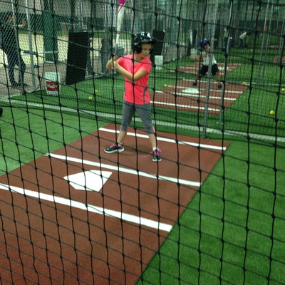
- Criteria #8 - Environmental DESIGN
- Criteria #9 - Fees and Hours of Operation
- Criteria #10(B) - PROJECT benefits

Dinuba Recreation and Activity Center, City of Dinuba SPP.

Definitions for All Words and Terms in Small Caps
acquisition – to gain ownership of land or obtain a permanent easement. A lease or rental is not considered ACQUISITION.
ADJACENT – property next to or across the street from a PARK that existed before the APPROPRIATION DATE.
APPLICANT – an entity requesting GRANT funding through a competitive process.
APPLICATION – the required attachments listed in the APPLICATION Checklist on page XX.
APPROPRIATION DATE – begins on July 1 of the State of California fiscal year when program funding is authorized by the legislature.
AUTHORIZED REPRESENTATIVE – the position appointed by the APPLICANT’S governing body to sign all required GRANT documents. The AUTHORIZED REPRESENTATIVE can designate an alternate by informing OGALS in writing.
BROAD REPRESENTATION – the inclusion of DESIGN ideas from RESIDENTS who may have different recreational needs, including youth, adults, older adults, and families. Inclusion of people with disabilities, single adults, and immigrants are also encouraged. Sole involvement of an advocacy group or league likely to promote a specific RECREATION FEATURE does not meet this intent.
challenges – conditions present in a community affecting the HEALTH and quality of life for YOUTH AT HIGH RISK, adults, older adults, and families. Examples include a lack of safe and affordable recreational opportunities, low performing schools, poverty, high crime rates, brown fields, residential overcrowding, and physical barriers such as freeways and rivers disconnecting neighborhoods.
climate change - a long-term shift in temperatures and weather patterns, primarily driven by human activities such as the burning of fossil fuels. This change poses significant risks including extreme weather events, rising sea levels, and impacts on ecosystems and human health.
climate vulnerability - Communities with a disproportionately heightened risk or increased sensitivity to extreme heat, wildfire, sea level rise, drought, and flood within the proposed project site.
COMMITTED FUNDS – cash in hand or having a contract or other binding agreement with another entity(s) obligating the additional funds needed to complete the project. Future fundraising plans are not COMMITTED FUNDS. COMMITTED FUNDS must be secured by application deadline.
conservation corps
- California conservation corps (CCC) – a state-certified local workforce development program that employs 18 – 25-year-olds for environmental conservation or enhancement projects, fire protection, and emergency response. See www.parks.ca.gov/spp for CCC website.
- California Association of Local conservation corps (CALCC) – nonprofit organizations certified by the California conservation corps to provide community and conservation work, education, and job training. See www.parks.ca.gov/spp for CALCC website.
CONSTRUCTION COSTS – costs incurred starting when ground-breaking construction activities such as site preparation, grading, or gutting begins, and continuing to the end of the grant performance period.
CONCEPT LEVEL SITE PLAN - must show each distinct and separate recreation feature and major support amenity, consistent with what is listed on the grant scope/Cost Estimate Form.
CORPS MEMBERS – youth enrolled in the California Conservation Corps and/or Community Conservation Corps, as defined by Public Resources Code 14507.5
COVERED PARKS – a large shade or snow protection structure over sports fields, courts, or playgrounds, in California, where weather would otherwise diminish seasonal outdoor recreation.
CRITICALLY UNDERSERVED COMMUNITY – an area within proximity of a project site that has a ratio of less than three acres of park space per 1,000 residents or is below the median household income threshold based on the response to Project Selection Criteria #1 or #2.
DAILY ACCESS – after project completion, youth, adults, older adults, and families affected by poverty can use the project seven days a week with no fees or affordable fees.
DESIGN – preliminary project concepts and drawings achieved through the community-based planning meetings, before the completion of engineer/construction documents.
DESIGN ELEMENTS – detailed design ideas, for the function and appearance of a recreation feature or major support amenity. These can include, but are not limited to, theme, color, size, layout, shape, material, public art enhancements, or other structural enhancements, specific to the proposed recreation feature or major support amenity.
DEVELOPMENT – to construct a new recreation feature or major support amenity, or renovation of an existing recreation feature.
DISTRICT – one of the following as defined in SPP legislation:
- A recreation and PARK DISTRICT formed under Division 5 of the Public Resources Code, Chapter 4 (commencing with Section 5780).
- A public utility DISTRICT formed under Division 7 (commencing with Section 15501) of the Public Utilities Code in a non-urbanized area that employs a full-time PARK and recreation director and offers year-round park and recreation services on lands and facilities owned by that district.
- A memorial DISTRICT formed under Chapter 1 (commencing with Section 1170) of Division 6 of the Military and Veterans Code that employs a full-time park and recreation director and offers year-round PARK and recreation services on lands and facilities owned by that DISTRICT.
- The Malaga County Water District exercising powers authorized under Section 31133 of the Water Code.
- A community service DISTRICT formed under Division 3 (commencing with Section 61000) of Title 6 of the Government Code in a nonurbanized area that is authorized to provide public recreation as specified in subdivision (e) of Section 61100 of the Government Code.
- A county service area or zone in the county service area, within the County of San Bernardino that is empowered to provide public PARK and recreation services pursuant to Chapter 2.2 (commencing with Section 25210.1) of Part 2 of Division 2 of Title 3 of the Government Code, that is actually providing public PARK and recreation services that was reorganized prior to January 1, 1987, from a PARK and recreation DISTRICT to a county service area or zone.
- A regional PARK DISTRICT formed pursuant to Division 5, Chapter 3, Article 3 (commencing with Section 5500) of the Public Resources Code.
ELIGIBLE COSTS – expenses directly related to the completion of the GRANT SCOPE, and which may be charged to the GRANT if (1) there is a fully executed CONTRACT between the GRANTEE and OGALS, (2) incurred during the GRANT PERFORMANCE PERIOD, (3) consistent with the ELGIBLE COSTS chart.
EXISTING PARK – public land that includes open space with at least one officially designated RECREATION FEATURE and is open to the public for recreation before the APPROPRIATION DATE.
EXPAND/EXPANSION – the PROJECT will add PARK SPACE acreage to an existing ADJACENT PARK. The expansion property is not park space and has not been part of the adjacent park before the current round’s application due date.
GRANT – amount of funds made available to a GRANTEE for completion of the GRANT SCOPE during the GRANT PERFORMANCE PERIOD.
GRANT CONTRACT – an agreement between OGALS and the grantee specifying the performance of the grant scope within the grant and contract performance periods, and other obligations between the grantee and OGALS.
GRANTEE – an entity having a CONTRACT with DPR for a GRANT funded by the Statewide Park Program.
GRANT ADMINISTRATION GUIDE – the guidelines posted at www.parks.ca.gov/spp that provide requirements and forms for GRANT administration after an APPLICATION is selected for funding.
GRANT PERFORMANCE PERIOD – the period of time, starting with the APPROPRIATION DATE, when ELIGIBLE COSTS may be incurred by the GRANTEE and charged to the GRANT. Dates for each ROUND will be posted at www.parks.ca.gov/spp.
GRANT SCOPE – the RECREATION FEATURES and MAJOR SUPPORT AMENITIES listed in the GRANT SCOPE/Cost Estimate Form that must be completed prior to final GRANT payment. Also see the definitions of TOTAL PROJECT COST.
HEALTH –physical, mental, and social well-being, not merely the absence of disease.
HEALTH ORGANIZATION – a government, foundation or community-based organization, or private entity with a primary mission of promoting community design principles supporting physical activity, active transportation, social wellness, mental wellness, nutrition, housing-related anti-displacement strategies, and a thriving environment.
INDIRECT COSTS – (Also known as incidental, overhead, or administrative costs) are the costs of doing business that are not directly related to carrying out the grant-funded project but are necessary for the general operation of the grantee organization. These costs are established through a methodology that calculates a cost base such as a Cost Allocation Plan. Costs may include but are not limited to: rent/mortgage payments, utilities, telephones, internet, computers/software/IT expenses, office supplies, property taxes, janitorial, human resources, business services, etc. Certain types of indirect costs are not allowed including food and beverages, fundraising, lobbying, and entertainment.
JOINT POWERS AUTHORITY – an agreement between a City, County, and/or a DISTRICT to perform services, cooperate with, or lend powers for the operation and maintenance of PARK land. For a joint powers authority to be eligible, one of the following must be a member: a City, or a County, or an eligible DISTRICT.
MAJOR SUPPORT AMENITY – means either of the following:
- A support facility that serves the PARK or supports the recreational experience, such as a parking lot, restroom building, storage/maintenance building, snack shack/concession stand. These types of support facilities need to be listed on the GRANT SCOPE/Cost Estimate Form regardless of the estimated cost; or
- A support improvement located “throughout the PARK” that enhances safety, access, beautification, or overall park use, but is not directly tied to a specific RECREATION FEATURE. Examples include lighting, access pathways, signs, benches, landscaping, perimeter fencing, and security cameras. These types of support amenities need to be listed on the GRANT SCOPE/Cost Estimate Form only if the estimated cost is $50,000 or greater. See definition of MINOR SUPPORT AMENITIES if the estimated cost is less than $50,000.
MEDIAN HOUSEHOLD INCOME THRESHOLD – the area located within a half mile radius of the PROJECT SITE is at or below 80% of the statewide median household income average, qualifying as a disadvantaged community as defined by Public Resources Code sub section 75005(g). If the area located within a half mile radius of the PROJECT SITE is above 80% of the statewide average, it must have a ratio of less than three acres of PARK SPACE per 1,000 RESIDENTS to be eligible.
- The MEDIAN HOUSEHOLD INCOME THRESHOLD for the current ROUND will be posted at: www.parks.ca.gov/spp.
MEETING – RESIDENTS worked together as a group in person with the APPLICANT or with the APPLICANT’S partnering community-based organization(s) to DESIGN the PARK. The type of MEETING can be creative, cost effective, and non-traditional. Formal public hearings are not required.
MINOR SUPPORT AMENITIES – permanent support items such as signs, benches, drinking fountains, fixed bicycle racks, trash receptacles, and tables estimated to cost less than $50,000. Fold the cost of MINOR SUPPORT AMENITIES into the cost of RECREATION FEATURES. See definition of major support amenities if the estimated cost is greater than $50,000.
NEW PARK – the PROJECT will create a PARK on property that was not open as a public PARK prior to the APPLICATION deadline and is not ADJACENT to an EXISTING PARK.
NEW RECREATION OPPORTUNITY – construction of a new RECREATION FEATURE., or RENOVATION of an existing RECREATION FEATURE that will be improved beyond its original condition.
NONPROFIT – an entity with current tax-exempt status under Section 501(c)(3) of the federal Internal Revenue Code (IRS) and registered with CA Registry of Charities and Fundraisers.
OUTDOOR LEARNING OPPORTUNITIES – employment or volunteer activities for RESIDENTS or CONSERVATION CORPS members during community-based planning and PROJECT DESIGN, or by PROJECT COMPLETION.
PARK – open space land for the general public’s physical and social HEALTH that provides at least one designated RECREATION FEATURE for nature appreciation, athletic activities, cultural enrichment, or other recreational activities.
- A PROJECT that is only for a stand-alone community center, that is not currently in a PARK or ADJACENT to a PARK, would be considered ineligible as SPP PROJECTS must create, EXPAND, or improve PARKS.
- School property is considered a PARK when there is a joint-use agreement and PARK signage indicating the general public is welcome to use a designated outdoor area, such as a schoolyard, for recreation during appropriate hours such as after-school, weekends, and summer.
PARK SPACE – the size of the official PARK boundary determined by acres or fraction thereof.
partnership – a public agency, nonprofit organization, company, community organization, or other entity, that is assisting the applicant to achieve one or more goals related to Project Selection Criteria 3 - 4 and 6.
PRE-CONSTRUCTION COSTS – costs incurred before construction during the planning, DESIGN, and permitting phase of the PROJECT. Costs are limited to 25% of the GRANT amount.
PROJECT – the RECREATION FEATURES and MAJOR SUPPORT AMENITIES listed in the GRANT SCOPE/Cost Estimate Form to be funded by the GRANT request and COMMITTED FUNDS.
PROJECT COMPLETION – when the RECREATION FEATURES and MAJOR SUPPORT AMENITIES listed in the GRANT SCOPE/Cost Estimate Form are complete and the facilities are open and useable by the public.
PROJECT SITE – the entire PARK property. When using the California State Parks Community FactFinder, the origin of the half-mile radius can be located at any point within the boundary of the entire PARK.
PROXIMITY – the area located within a half-mile radius of the PROJECT SITE.
RECREATION FEATURE – an element that provides active or passive recreational use.
RENOVATE/RENOVATION – construction to improve an EXISTING PARK to either increase public use, operating hours, public safety, energy or water conservation, accessibility compliance, or all the above. RENOVATION of a RECREATION FEATURE or MAJOR SUPPORT AMENITY means all or a portion of the original structure will remain and be improved for public use in an EXISTING PARK. The project will not expand an existing park or create a new park.
RESIDENTS – the population living within a half-mile of the PROJECT SITE including youth, families, adults, tribes, and older adults.
ROUND – a distinct cycle of APPLICATIONS received and reviewed by DPR, through a competitive process.
SITE CONTROL – when the GRANTEE owns the PROJECT SITE, or has a permanent easement, or has a lease agreement or TURNKEY agreement approved by DPR, that allows for PROJECT COMPLETION and public use to fulfill the CONTRACT obligations.
TOTAL PROJECT COST – the combined dollar amount of all funding sources used to complete the RECREATION FEATURES and MAJOR SUPPORT AMENITIES listed in the GRANT SCOPE/Cost Estimate Form.
TURN-KEY PROJECT – a proposal by the APPLICANT to complete the PROJECT, and then transfer the GRANT CONTRACT obligations, only if approved by OGALS, to an eligible agency for long term operation and maintenance.
YOUTH AT HIGH RISK – CHALLENGES within the CRITICALLY UNDERSERVED COMMUNITY affecting the HEALTH and wellness of youth such as, insufficient recreational programs as positive alternatives to gangs, pollution, or a blighted environment.
vulnerable populations – A subgroup of population within a region or community that faces a disproportionately heightened risk or increased sensitivity to impacts of climate change and that lacks adequate resources to cope with, adapt to, or recover from such impacts.

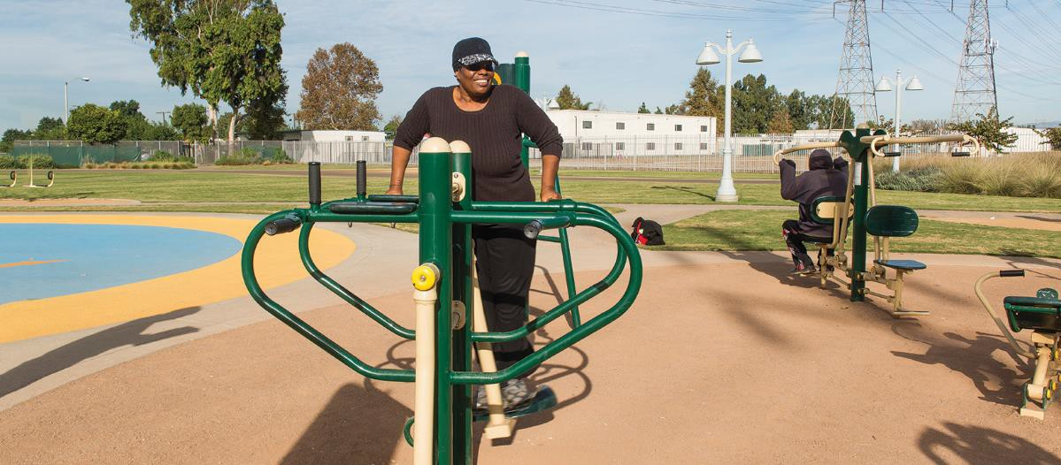
“I made it a goal to walk two miles each day on this park’s track with a group of retired friends. Then I use the outdoor gym equipment. I lost many pounds. It is a positive movement to a healthy lifestyle.” – Salud Park user

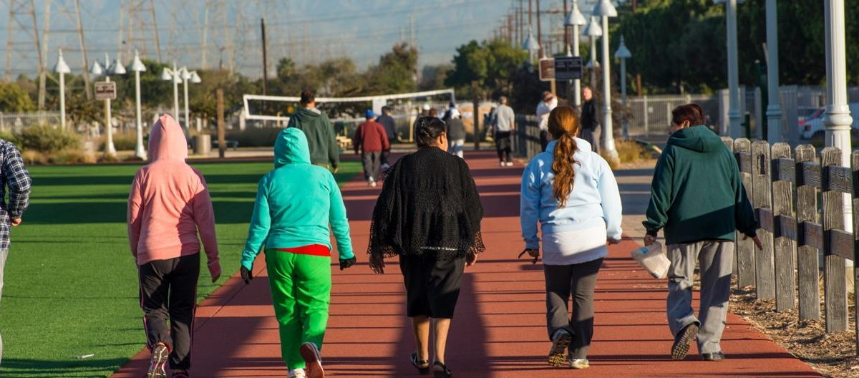
The creation of Salud Park in the City of Paramount is an example of this program’s legacy.

PROGRAM WEBSITE S: parks.ca.gov/spp | parksforcalifornia.org/communities

