Lottery Application for 2022 Weddings @ Sugar Pine Point State Park
Due to the popularity of weddings at the Hellman-Ehrman Mansion at Sugar Pine Point State Park, we often receive more requests than the number of available dates. Therefore, we conduct a lottery to schedule wedding dates. If you wish to be considered for a 2022 wedding, please submit this form to the Special Events Office no later than May 12, 2021. Lottery applicants will be contacted with their date no later than May 31, 2021. No phone calls, please!
Event Type: |  | Full Wedding (Ceremony & Reception) |  | Ceremony-Only Event
Names of Wedding Couple: (one lottery entry per couple)
Contact Email: |  |  | Contact Phone:

Your Requested Wedding Dates:
Please indicate your preferred dates below. The season runs 6/10-9/19. Please note that we do not allow special events on holiday weekends, due to the high number of park visitors, and on weekends reserved for other large events. For 2022, these unavailable dates are 7/1-5, 8/19-21, 9/2-4 and 9/9-11; your date choices below should therefore not include these dates.

1st Choice of Date: | 2nd Choice of Date: | 3rd Choice of Date:

Process:
*Full wedding events take priority and will be drawn first in the lottery, followed by ceremony-only events.
*When randomly drawn in the lottery, applicants will be scheduled for their first available choice of date.
*We will contact you by email with your scheduled date no later than May 31, 2021. Please, no calls!
*You have 24 hours to respond confirming interest in the date. Once confirmed, your date is placed on a two-week hold.
*If you do not confirm the date within 24 hours of being contacted, it will be forfeited and opened to other applicants.
*To secure your date, a signed contract and $1,000 non-refundable deposit is due before the end of the two-week hold.
*If you do not secure your date within the two-week hold, it will be forfeited and opened to other applicants.
*After all two-week holds have expired, all open dates will be published and available on a first-come first-served basis.

Fees:
*The $1,000 non-refundable deposit is payment toward your venue fee, but non-refundable in the event of cancellation.
*Final venue fees are due 2 months prior to your wedding.
*All venue fees are non-refundable should you cancel the event for any reason, including inclement weather.
*A $1,000 refundable security deposit are proof of liability insurance are due one month before your wedding.

Advance Site Tour:
*We strongly recommend that you conduct a self-guided site tour before entering the lottery or booking a date.
*If you book a date, a guided site tour in advance of your wedding is required, to better plan for a successful event.
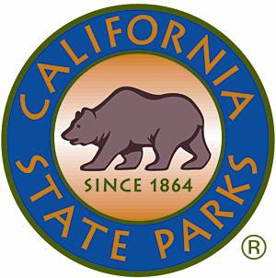
*Contact us for a self-guided tour brochure and/or to schedule your required site tour (limited availability Oct-Apr). Thank you,
Special Events Office
California State Parks - Sierra District / Lake Tahoe Sector PO Box 266, Tahoma, CA 96142
Phone: (530) 525-5060 // Email: lssec@parks.ca.gov

